Education Management Software Policy
2015+

Board of Management Scoil Bhríde Nurney
2015+
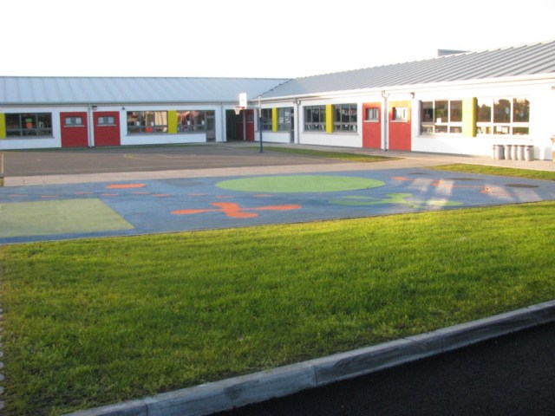
Scoil Bhríde

Education Management Software Policy

Introduction:

In Scoil Bhríde we use the Aladdin Software package as part of our every day Education management. This policy sets out why we use it, who can access the data, when we use it and how we use it.
Rationale:
It allows staff to access information on pupils quickly, it streamlines attendance recording, it reduces paperwork, improves planning, simplifies reporting and gives management up to date information on all children in the school.
Who has access to the data?
All teachers have access to the information on children in their classes. This also applies to learning support teachers and resource teachers. Information inputted on children stays on the child’s file and moves from year to year as children move class. The School Secretary acts as one of the administrators to the school site and has access to the pupil’s personal details which sometimes have to be changed. The school secretary does not have access to the educational files relating to the children. The school principal and deputy principal have access to all files on the school site: both personal details and educational files relating to the children.
When it is used?
We use the Aladdin software on a day to day basis in our school. All mainstream teachers are instructed to fill in the daily attendance at 10.20 a.m. Under Circular 33/15 it states “) If they use an electronic system for recording attendance of pupils, schools no longer need to also maintain the Leabhar Rolla in hard copy format, subject to such electronic system meeting certain minimum requirements as set out in Appendix 1 of this Circular. (iii) If they use an electronic system for recording attendance of pupils, they may use that system as an alternative to the Department’s excel version of the Leabhar Tinrimh Laethúil that is available on the Department website, subject to such electronic system meeting certain minimum requirements as set out in Appendix 1 of this Circular.
“Allow for legitimate updating of records outside of the normal timeframes for same e.g. a power cut on a given day might prevent a school from updating its data on that day. It is recognised that access to an electronic system may not always be possible (for technical or other reasons) at the time when required and that from time to time, it may be necessary to input data records (such as the roll call) to the system at a later stage when such access is restored. However, the system must provide that where data entries are made outside of the normal timeframes (e.g. after the normal period allowed for roll call) the system user concerned must be required to input the reason for same and that all such late entries are clearly identifiable and distinguishable (e.g. by the records being displayed in a different colour from others) from other records. In any case where data entries are made outside of the normal timeframes, the school is required to print and retain a copy of same and this must be made available to the Department if requested.”- If you cannot access the software during the day please update your class attendance at break times.
How do we use it?
We use the electronic roll section as part of our daily attendance duty as detailed in Circular 33/15. This is mandatory and has replaced the Leabhar Rolla. At the end of each term the attendance sheet must be printed out and placed in a folder which will be kept in the principal’s office.
Under school policy all late arrivals (Any child who arrives after 9.40 am) and early collections must be entered into the Aladdin site. (You can do this at the end of the school day).
All notes relating to major disciplinary matters can be entered on the Aladdin site. This can relate to issues in the yard and in the classroom. When a child is constantly not doing their homework this can also be entered. Please keep short notes on any meetings you have with parents throughout the school year- this does not apply to our annual parent/teacher meetings.
We use the Software to report on children’s progress throughout the school year including the end of year report which includes standardized test results.
Teachers are also asked to input results in class test results throughout the year. These may include spelling tests, phonic tests, history and geography tests, termly maths and Gaeilge tests. At the end of the year yearly averages may be given in the end of year child’s report. It is important that this data is inputted as these results are available to the class teachers who will have these children in future years.
When a teacher is absent?
When a teacher is absent the substitute teacher will get the daily attendance and make a note of it for the teachers return. This also applies to late arrivals and early collections.
Can Parents access their child’s information?
Upon a written request parents can gain a paper record of their child’s attendance records, academic records and personal data. Written requests must be made to the school principal or the Chairperson of the Board of Management.
Use of the Notice Board feature
All staff can send messages relating to educational/school matters using the notice board feature. Policies which are being updated and reviewed will be sent using this facility and can then be downloaded onto staff laptops.
NEWB/TUSLA returns
The software will be used to maintain NEWB/TUSLA returns. It is important therefore that reasons for children’s absences are maintained accurately.
October Returns
The Software will be used to fill out the October returns which are mandatory. It is vitally important that all data on the school site is accurate as it used to fill in the October returns form which cross checks information on previous years returns.

Ratification of Education Management Software Policy

This policy was adopted by the Board of Management on _________________

Signed: _________________________ Signed: __________________________
Chairperson of Board of Management Principal

Date: __________________________ Date: __________________________

Date of next review: __________________

