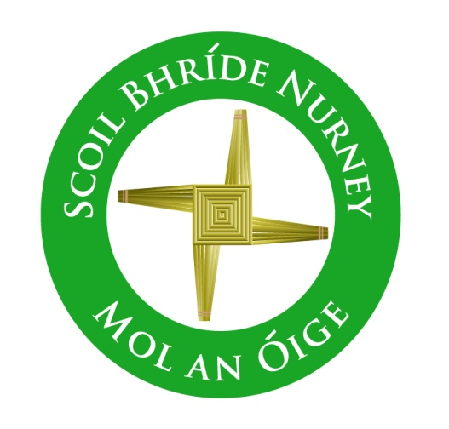
Geography Policy
2021+

Board of Management Scoil Bhríde Nurney
2021+
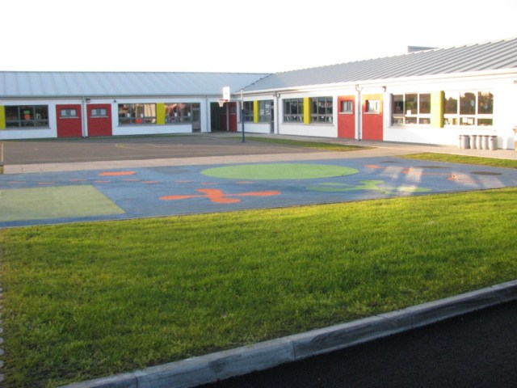
Scoil Bhríde

Geography Policy

Introductory Statement
This Geography Plan was drawn up in consultation and collaboration with staff members and its preparation involved review of current practice, research of Curriculum documents, NCCA materials and references to other materials and resources available in our school.

Rationale
Our plan has been designed to benefit the teaching and learning of Geography throughout our school. It provides an overview of the Geography curriculum and outlines our general aims and goals with regard to this subject. Our plan also provides frameworks for long term and short-term classroom planning for teachers. This plan is also designed to inform teachers (full time and temporary), our Board of Management and our parents and guardians of the approaches and methodologies used in teaching Geography.

Vision
We seek to assist the children in our school in achieving their potential. Our school hopes to promote a coordinated approach to the planning and teaching of Geography so as to ensure development and continuity and can facilitate the evaluation of learning, teaching resources and approaches and methodologies.
Aims
To provide the pupils of Scoil Bhríde Nurney with a geography programme that is developmentally appropriate and socially relevant.

To support the aims of the primary curriculum for geography by:

- Developing knowledge and understanding of local, regional and wider environments and their interrelationships
- Encouraging an understanding and appreciation of the variety of natural and human conditions on the Earth
- Developing empathy with people from diverse environments and an understanding of human interdependence
- Developing the ability to use a range of communicative methods, especially those concerned with the development of graphic skills (mapping and other non-verbal, non-numerical forms of data presentation)
- Encouraging the development of a sense of place and spatial awareness
- Encouraging the development of caring attitudes and responsible behaviour towards the environment, and involvement in the identification, discussion, resolution and avoidance of environmental problems
- Developing an understanding of appropriate geographical concepts.

The scheme covers the three strands of the geography curriculum:

- Human environments
- Natural environments
- Environmental awareness and care

The following skills span the content of each of these three Strands:

- A sense of place and space
- Maps, globes and graphical skills
- Geographical investigation skills
The content of the Geography Scheme builds on the work at each prior level and will consolidate and develop the pupils’ experience, skills and geographical knowledge in an environment that promotes enthusiasm, curiosity and creativity in the child.

Linkage and Integration
At each class level the teachers will seek to integrate Geography with other curricular areas. Teachers will make provision for this linkage in their short-term planning.

Methodologies
A variety of methodologies is an important aspect of the geography programme as it helps children with differing learning styles to access the curriculum.
The following approaches will be employed to enhance each child’s geography education;

- Talk and discussion-includes discrete teaching of discussion skills such as: turn –taking, active listening, positively responding to peers, clarity and confidence in giving opinions
- An active learning hands on approach- in an attempt to develop skills through content
- Collaborative and cooperative learning – pairs or groups, linking with other schools, project work
- Geographical Language-for example whilst presenting the findings of research to the class or school
- Photos and artefacts-recognising and examining features in photographs and artefacts
- Interviews and surveys-land use surveys, interviewing people living and working in the area, conducting a traffic survey
- Use of maps, globes and atlases-plotting routes
- Using models and simulations-for example to investigate mountain building or the abrasion of materials
- Use of story-for example the novels “Under the Hawthorn tree” or “Kensukes Kingdom”, visitors or relatives in the classroom, news items
- Problem-Solving-estimating, making a model, drawing a diagram, trial and error, making a table or chart of the information, patterns in problems, guesstimate, breaking down into parts, using manipulatives, acting out a problem, solving a simpler version of the problem
- Use of Environment- field work, observing and sketching features in the environment
- Technology- to be used as a tool/ aid throughout third class. Classroom P.C.- to be used as a teaching tool/ aid to create data bases, to create spread sheets and to access supplementary materials and information from the internet. Websites- http://www.nationalgeographic/magazine/.com (for more see below)

Equality of Participation and Access
This Geography programme aims to meet the needs of all the children in the school. This will be achieved by teachers varying the pace, content and methodologies to insure learning for all pupils. We view the Geography programme as playing a key role in ensuring equality of opportunity for all children. The programme at each class level will be flexible so that the learning requirements of all children may be addressed. We provide an equal educational experience for both boys and girls as we recognise that stereotyped expectations of gender roles can inhibit children’s educational achievements. Children with special needs will be included in all activities

Differentiation
Whole class teaching of geography will include a range of differentiation strategies by
- Differentiating learning objectives
- Differentiation by teaching style - using a mixture of whole class teaching and focused group work
- Differentiation by resource – for example using manipulatives or audio/visual resources or encouraging use of Geographical websites for further investigation / study or using more/less demanding maps
- Differentiation by task – for example involving weaker / less interested pupils in setting up work stations etc. to stimulate interest and develop vocabulary or providing opportunities for children to record and tell about their geographical work in a variety of ways such as oral presentations, drawing, modelling, computer aided work or providing opportunities for alternative investigation work
- Differentiation by outcome – for example modifying exercises to match the ability levels of pupils for example map work involving more/less demanding maps
- Differentiation by grouping – for example using a ‘Buddy’ system to increase involvement of weaker pupils and give a sense of responsibility and caring for the more able or rotating group leaders when engaging in group work
- Differentiation by support – for example a list of the terminology used in geography is given to the Support teacher or intervening to give the tuition they need as the children are engaged in learning activities

Assessment
Assessment is a continuous, dynamic and often informal process. Assessment in Geography will assess the child’s knowledge and understanding of environmental matters, the acquisition of geographical concepts and skills and the development of important attitudes and values
The following assessment tools will be used;

- Teacher observation-this is ongoing and will be used to assess
- the responses the child makes to teacher questions and suggestions
- the participation of the child in the whole-class discussion of geographical features, processes, interactions and phenomena
- the way in which the child may identify and discuss environmental issues in a variety of environments
- the participation of the child in efforts to enhance the environment and to solve environmental problems
- the interaction of the child with others in discussions and group work
- the reaction of the child to learning materials.
- Teacher designed tasks and tests-including
- giving oral, written or pictorial accounts and descriptions of environmental factors observed or studied
- collecting information from sources such as direct observation in the environment, interviews and books, electronic sources and the internet and other materials in the classroom and library
- observing accurately both inside and outside the classroom
- predicting outcomes of an investigation
- estimating, measuring and comparing
- analysing objects and processes
- sorting and grouping people, events and natural phenomena
- recognising patterns
- completing work cards or activity sheets which guide the child towards fulfilling particular tasks
- undertaking a range of outdoor tasks
- displaying and reporting on completed project work and on work in progress
- using elements of graphicacy
- using interactive multimedia computer programs which enable the child to explore geographical themes and topics and complete a range of tasks, puzzles or problems
- using maps and globes
- completing independent geographical research, recording and presenting the results
- completing teacher-designed revision tests on a unit or units of work
- engaging in practical environmental investigation or enhancement
- asking questions about aspects of the environment.
- Concept mapping-pictorial and word-based relationship charts

- Work samples-written work or digitally stored samples used to affirm children’s progress and development, such as

- Map work
- Photographs of models constructed and areas visited
- Completed trail booklets
- The results of project work
- Record sheets from experiments

- Pupil profiles-compilation of test results and work samples, kept in folder in classroom and used for reporting to parents and other teachers.

- Curriculum profiles-used to record progress as children demonstrate mastery of indicators such as
- The child can name and show on a map the rivers of Leinster
- The child can align a map correctly

- Standardised testing- Micra –T and Sigma – T administered to all pupils according to the school’s assessment policy

- Diagnostic testing-administered by the support teacher, subsequent support strategies devised in consultation with class teacher etc.

Parental/Guardian Involvement
Some ways in which our parents/guardians can get involved include:
- Helping their children to gather photos, newspaper cuttings and other resources to support the teaching of geography.
- Looking at & discuss work in science on the websites listed on the school website
- Getting other people involved in the geography curriculum: helping to organise visitors to speak e.g. grandparents, retired teachers & other older members of the community
- Our Parents Association is helping to fund some of our field trips.

Health & Safety
We are cognisant of the need to keep everyone and everything safe as we explore our environment. We teach children the rules and procedures for health & safety before and during walking trips and bus trips (this integrates with SPHE). The need to listen, respect and do as others tell us while is strongly emphasised.

Staff Development
- Teachers have access to reference books, resource materials, and websites dealing with Geography.
- Each teacher is responsible for keeping these resources up to date and to have these available to share.
- At times there may be appropriate SESE courses available. Teachers are encouraged to attend.
- Teachers are encouraged to share the expertise acquired at these courses as well as other aspects of the subject. This is organised at staff meetings.
- Working with local people who have good geographical knowledge of the area benefits teachers and children alike.

Individual Teacher’s Planning and Reporting
Teachers will base their yearly and short-term plans on our whole school plan for Geography. Please refer to the attached whole school SESE planning guide for each class.

Teachers will consult this whole school plan and the curriculum documents for Geography when they are drawing up their long and short-term plans, ensuring that the correct strand units under each strand are taught.
Each teacher's Cuntas míosúil will assist in recording work covered and in evaluating progress in Geography and informing future teaching and learning.
Parents are informed of children’s progress in geography at parent teacher meetings and in end of year report cards.

Organisational Planning
- Timetable
As per curriculum guidelines – SESE
- Infant Classes (2 hours 15 minutes per week)
- 1st – 6th Classes (3 hours per week)

SESE Project Fair
A simple project Fair is held annually in the school Hall (during the month of __________) with a different focus on one SESE subject project per year. All classes participate and the Fair is open to the public and other classes within the school (e.g. year 1 – Science, year 2 – History, year 3 – Geography etc.)

Resources

The following resources may be available and used in the delivery of the Geography Programme (this list will be updated after each review when possible):

Human environments | Natural environments | Environmental awareness and care
The environment itself  Photographs  Various maps- (physical, road, ordnance, house plan, tourist, local, street plans)  Atlas  Text book ‘Geography all around me’  Text book and workbook ‘Earthlink 3’  Large road map of Ireland  Mapping graph paper  Japanese gardens field activity worksheets  Know, want to know and learned board signs  Computer software for drawing simple graphs  Pictures of the local area  A camera  Local newspapers  Local shopkeepers and employers  Katie Morag and the two grandmothers- by Mairi Hedderwick (Bodley Head (hardback), Red Fox (paperback and big book))  Pictures and photographs of Coll in the Inner Hebrides, on which the island of Struay is based, or a similar island  Materials for making a collage  World map  Profiles of holiday makers  Blank base maps  Display material  Photographs  CD-ROMs and brochures of holiday destinations  Blank postcards  ‘Passports’  Access to the internet  Lucy and Tom at the seaside by Shirley Hughes | The environment itself  Mixed rock pack  Window pane thermometer  Torches, sundials, shadow sticks  Photographs (including aerial)  Plastic cylinders and hand lenses  Weather Vanes, anemometer, rain gauge  Trundle wheel, metre sticks or tape measures  Sun shadow investigation kit  Rain gauge, barometer  Globe, various maps and atlas  Large physical map of Ireland  National Geographic video ‘The planets’  PowerPoint presentation ‘The water cycle’  Laptop computer and graphing software  Bottles, sticky tape and scissors  Worksheets ‘the weather’ and ‘the water cycle’  ‘Make a rain gauge teacher resource sheet  How does your country compare work sheet  Shackleton expedition worksheet  Antarctic map worksheet  Antarctic altitudes worksheet  Sieves, timers and measuring jugs or cylinders  Containers for soil tests  Pictures/video (showing landscapes with and without visible rocks and different soils)  Samples of different soils  Measuring tapes, ranging rods, floats  Stopwatch, clipboards and compass  Combs with widely spaced teeth, cardboard tubes  Objects of a variety of shapes  Collection of opaque, transparent and translucent Objects and materials eg plastic bottles, fine gauze, thin nylon, wood, acetate, foils, greaseproof paper  White cardboard to act as screen  Overhead projector | The environment itself  Litter pickers  Clipboards  A base map of school and grounds  Weighing scales  Litter-pickers and gloves  Spreadsheet and simple graphing software  A camera  Local authority contact details  Blindfolds  Bean bags and obstacles  Model of the eye  Story and information books about the eye  A selection of glasses  Graphing software  A local optician  A video on charity eye projects
General Resources
- Small World by CJ Fallon
- A variety of textbooks and the Local library
- Photos, newspaper cuttings & other resources brought in by children/parents/teachers
- Relevant software
- Visualisers - this allows teacher to use one book with the entire class.
- Geography trails - local and further afield.
- Use of interactive whiteboard.

Areas of interest (local and further afield)
- Kildoon Woods
- Nurney stream
- Nurney Playground and gardens
- Pigeon House
- School field
- School Garden
- Nurney Church
- Curragh Plains
- National Stud and Japanese Gardens
- Solas Bhríde grounds
- Saint Brigids Well
- Pollardstown Fen

Website | Information
www.geography.org.uk | Publishers of Primary Geography Handbook
www.earthscienceireland.org
www.geology.ie
www.acblack.com
www.iqua.ie | Archaeology and paleontology
www.cso.ie | Central statistics- office ed section
www.enfo.ie | Enfo is a service on environment, heritage & local government
www.treecouncil.ie | Charts & posters
www.scoilnet.ie
www.ncte.ie
www.epa.ie/education | (environmental Protection Agency)
www.opw.ie | Office of Public Works
www.sei.ie | Sustainable Energy Ireland
www.irish-architecture.com
www.irelandinformationguide.com | Info on counties
www.countytyrone.com | Substitute Tyrone for information on another county
www.trocaire.org
www.met.ie
www.bordglas.ie
www.multimap.com | Maps & aerial photos
www.graphicmaps.com | World atlas
www.imagesoftheworld.org
www.webshots.com
www.worldinfozone.com
www.cia.gov/cia/publications/factbook/geos/et.html | Countries factbook
www.picsearch.com
www.agriaware.ie
www.failteireland.ie
www.concern.ie
www.developmenteducation.ie
www.science.ie
www.oiche.ie
www.nasa.gov
www.wateraid.com
www.mapzone.com
www..kingfisherpub.com
www.scholastic.ie
www.ncca.ie
www.ria.ie | 22 towns available nationwide

Success Criteria
The success of this plan will be measured using the following criteria:

- Teacher observation.
- Teacher designed tasks and tests.
- Samples of children's work e.g. projects, portfolios, art displays.
- Feedback from pupils and parents.
- Inspectors’ suggestions/feedback.
- Staff meetings so that time is given to discuss, review and amend if necessary.

Roles and Responsibilities
Class teachers are responsible for the implementation of the Geography programme in their own classes.

Ratification of Geography Policy

This policy was adopted by the Board of Management on _________________

Signed: _________________________ Signed: __________________________
Chairperson of Board of Management Principal

Date: __________________________ Date: __________________________

Date of next review: __________________

