Substance Use Policy
2015+

Board of Management Scoil Bhríde Nurney
2015+
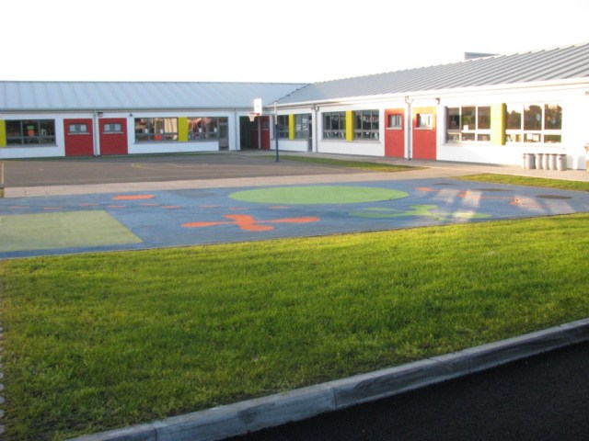
Scoil Bhríde
Substance Use Policy

Scope.
This policy applies to all users of the school building inside and outside of school hours. In this policy, our understanding of ‘drugs’ is as follows:
‘A drug is any chemical which alters how the body works or how the person behaves or feels’.
The Substance Use Policy is applicable to all school related activities and any exceptions will be discussed with the Principal and/or Chairperson of the Board of Management.
Relationship to School’s Ethos/Vision/Aims.
The characteristic spirit of the school (school ethos) has been developed and agreed with the partners in education, i.e. Board of Management, Staff, Parents. The Substance Use Policy reflects the school ethos in that it is dedicated to the care of the whole school community and it aims to provide a safe and secure environment for learning.
Rationale: Why is this policy necessary?
- The world in which we live presents young people with many challenges which affect their health and well-being. Exposure to alcohol, tobacco and drugs is part of this reality. Schools need to reflect upon how they might provide for the needs of their students and respond appropriately to what are sometimes sensitive and emotive issues.
- The Education Act 1998 provides that schools should promote the social and personal development of students and provide health education for them.
- The National Drugs Strategy ‘Building on Experience’ is now government policy and it requires schools to have a Substance Use Policy in place.
- The recent report from the National Advisory Committee on drugs entitles ‘Drug Use Prevention’ (November 2001) underlines the importance of schools developing substance use policies.
- The 1999 European School Survey Project on Alcohol and other Drugs (ESPAD) Report highlighted the seriousness of the problem among sixteen year olds in Ireland, as compared to the other 29 ESPAD countries surveyed. Alcohol was identified as being the dominant drug of misuse in Ireland whilst the use of tobacco and other drugs was above the ESPAD average.
- For the population as a whole, alcohol consumption per capita in Ireland has increased by 41% in the period 1989 to 1999, while other EU Member States showed either a decrease or a modest increase. Ireland now has the second highest per capita consumption of alcohol in the EU.

Objectives of the Policy.
The Substance Use Policy of Scoil Bhríde is intended:
- To highlight the clear procedures the staff of the school will follow in the event of a substance related incident.
- To better inform the school community with regard to Substance Use in all its guises. “The central objective of a school’s substance use policy is the welfare, care and protection of every young person in line with the Education Act, 1998 and the Education (Welfare) Act, 2000. The policy should address both education concerning alcohol, tobacco and drugs and the procedure for managing incidents relating to these substances”.
Policy Content.
The policy content is divided into three sections:
1. Education concerning substance use.
Education concerning substance use in Scoil Bhríde will be provided within the broad context of the subject of Social Personal and Health Education. SPHE was introduced formally into the school in September 2003. As part of our sacramental programme, confirmation candidates are encouraged to take the pledge to abstain from alcohol and illicit substance use.
Active learning strategies are advocated in the SPHE curriculum and will inform our selection of methodology. We will continue to treat many of the topics associated with Substance Use in the context of the Religious Education Programme as well as the SPHE programme. This may be reinforced by project work and by talks from local Gardai or Public Health Nurses. The content of their talk will be in keeping with the school curriculum.
The use of an outside visitor/speaker to enhance the work done in the class should always be considered in the context of the full SPHE programme and will be undertaken in the presence of a teacher.
2. Management of Alcohol, Tobacco and Drug-Related Incidents.
Young people are most at risk in relation to substance use in National School in
- the array of food and drink consumed in certain instances,
- use of glues and solvents,
- interaction with second level students at entertainment events.
Incidents relating to:
(a) alcohol, (b) tobacco and (c) drug use, are addressed in the school as follows:

(a) Alcohol:
The school is an alcohol free zone and pupils are not allowed to bring alcohol into the school or to consume alcohol in school or during any school related activities as per the scope of this Substance Use policy or at any stage within the school grounds.
If any member of staff thinks that a student is under the influence of alcohol, the Principal will be informed and Parents will be asked to attend at the school immediately. The parents will be required to give an undertaking that such an incident will not recur.
In general, if a student comes to school in an intoxicated manner or becomes intoxicated in school, he/she will be withdrawn from the class and parents requested to take him/her home. This will be done with regard to the right to privacy of the family concerned. Parents of the other children in the class will be written to and requested to monitor their children for any signs of alcohol consumption.
Students found breaking this rule must be cared for and may also need to be referred to the school Code of Discipline if the offence is repeated. Gardaí may be informed especially if the child/ren were supplied the alcohol – i.e. the alcohol was not stolen from the house as a one-off act of bravado. If the child continuously violates the rule, the school will have no choice but to report the matter to the duty social worker of the local Health Authority as this falls under the realm of neglect in the Children First Guidelines – guidelines all teachers must adhere to in relation to child protection. The school may be able to advise where support is available for that child in consultation with the relevant Health Authorities.
Permission to serve alcohol for a school related activity in which only adults will be present can be sought from the Board of Management.
Members of staff who present themselves for work in an intoxicated manner will be asked to excuse themselves from work for the day and the Chairperson of the Board of Management informed. The Chairperson will then decide on any action to be taken.
Parents who collect their children and are clearly under the influence of alcohol and intend driving them home will be advised that the school will seek the other parent/guardian listed on the school enrolment form to drive the child home instead.
Alcohol may only be used as prizes at school events with the permission of B.O.M.
(b) Tobacco:
Scoil Bhríde is a smoke-free zone in line with government legislation of 29thMarch 2004.
Tobacco products will not be used as prizes in school events.

(c) Illegal drugs/Solvents:
The school is an area where illicit drugs and non-water based solvents which affect the behaviour of children will not be allowed.
Any illegal drugs found on the school premises will not be disturbed unless leaving them in the location where they were found presents a risk to pupils. Gardai will be informed immediately and asked to remove the substances. No member of staff will transport illegal substances at any time.
If any member of staff suspects that a pupil is under the influence of an illegal substance, the Principal will be informed immediately and further action will then be decided.
In general, if a student comes to school under the influence of an illegal drug or comes under the influence in school, they will be withdrawn from the class and parents requested to take them home. Parents of the other children in the class will be written to and requested to monitor their children for any signs of substance use.
Students found breaking this rule must be cared for and may also need to be referred to the School Code of Discipline if the offence is repeated. Gardai will be informed. If the child continuously violates the rule, the school will have no choice but to report the matter to the duty social worker of the local Health Authority as this falls under the realm of neglect in Children First Guidelines – guidelines all teachers must adhere to in relation to child protection.
The B.O.M. will also be informed and may chose to take disciplinary action. Should it be deemed necessary by the teacher the emergency services may be contacted.
If the dealing of illegal drugs is suspected in the school, an investigation will be carried out. Parents of any students involved will be informed and the advice and assistance of the local Juvenile Liaison Officer of the Gardai will be sought.
Members of staff who present themselves for work under the influence of illegal substances will be asked to excuse themselves from work for the day and the Chairperson of the Board of Management informed. The Chairperson will then decide on any action to be taken based on the circumstances.
Parents who suspect their child is taking illegal substances should inform the school. The school may be able to advise where support is available for that child in consultation with the relevant Health Authorities.
For all school activities, the use of aerosols is prohibited and will be taken from the student if they are being used. These products will be returned to the parents of the child.
(d) Food and Beverages:
Certain children have a noticeable change in behaviour if fizzy/energy drinks and foods with a high sugar/salt content are consumed. The parents of the children will be encouraged not to include these items in their child’s lunch as per the healthy eating lunch policy.
3. Provision for training and staff development.
The shared understanding among the staff regarding the contribution that an SPHE programme can make to the prevention of substance misuse is evident through our adherence to the two-year plan for SPHE Curriculum and the use of the Walk Tall Programme.
Staff members are aware of the contribution they can make to the prevention of substance misuse within their own class by developing a supportive class environment and informing the pupils in an age-appropriate and socially relevant manner.
Staff members will be made sufficiently aware of and sensitive to the signs and symptoms of substance misuse by having appropriate training and information talks from the Gardai, relevant people within the Health Services, and Dept of Ed. Training.
Staff members have been made sufficiently aware of laws relating to alcohol, tobacco, and drug use and how they relate to themselves, to the school and the students.
Further training needs of teachers and parents in relation to the implementation of the substance use policy include revision of the signs and symptoms of Substance Use, e.g. Garda visit, information pamphlet and shall be addressed through P.T.A. meetings.
New staff, in particular, will be briefed on the substance use policy of the school on commencement of employment in the school.

Ratification of Substance Use Policy

This policy was adopted by the Board of Management on _________________

Signed: _________________________ Signed: __________________________
Chairperson of Board of Management Principal

Date: __________________________ Date: __________________________

Date of next review: __________________

