Pupils and Parents/Guardians Home Use of School Owned Assistive Technology Policy
2016+

Board of Management Scoil Bhríde Nurney
2016+
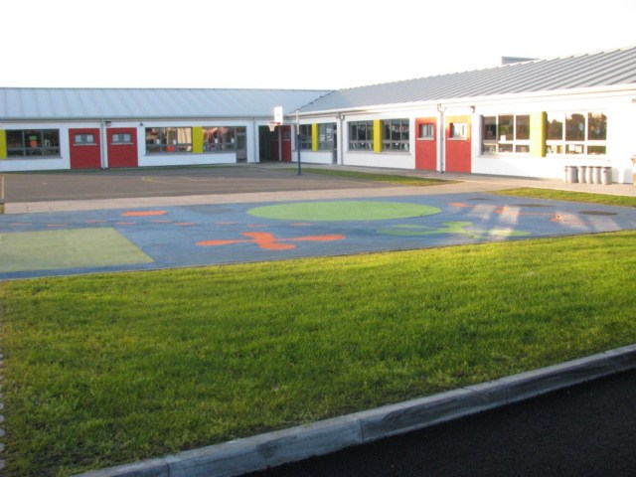
Scoil Bhríde

Pupils and Parents/Guardians Home Use of School Owned Assistive Technology Policy

Introduction:
This policy, the terms and conditions and the attached agreement was compiled in line with Department of Education and Skills Circular 10/2013 in relation to essential assistive technology equipment for pupils with physical or communicative disabilities.

Rationale:
The purpose of the document is to ensure clear guidelines for home use of specialist equipment which has been recommended by the National Council for Special Education (NCSE) as being essential for pupils who have been diagnosed as:

- having a serious disability
- and/or sensory or communicative disability to the extent that their ability to communicate through the medium of speech or writing is materially curtailed
- where it is clear that existing equipment in the school is insufficient to meet the child's needs
- where without such equipment it will not be possible for such children to access the school curriculum

Any equipment purchased by the school under Department of Education and Skills Guidelines remains the property of the school and should normally be kept in the school. However, the Board of Management may, in certain circumstances allow the use of the equipment in the pupil's home. Such circumstances are where it is agreed that the pupil could potentially benefit from, or achieve a degree of improvement to their academic and educational performance, their learning and their completion of homework through the use of technical support or equipment such as a school laptop.

This agreement endeavours to ensure the safe custody and handling of the equipment when in the care of the pupil outside of the school.

Procedure to allow Pupil to take Assistive Technology home

- Parent/Guardian must write a brief letter outlining the reason why they believe it is necessary for the pupil to bring the assistive technology home.

- The letter will be brought to the attention of the Board of Management and a decision made.

- Parent will be required to read in full and agree to the Terms and Conditions attached to this policy.

Terms and Conditions: Re: The Home Use of School Owned Assistive Technology

- The laptop remains the property of Scoil Bhríde Nurney, County Kildare.

- Should the designated pupil change school, including to post-primary, the school will consult with the SENO with regard to its transfer with the pupil where it is still appropriate for the pupil's assessed needs. The final decision regarding transfer will rest with the Board of Management.

- The laptop will be used solely by the designated pupil and will not be used by or transferred to a third party.

- The parent will remind and teach their child to take due care of the laptop at all times when handling, transporting and using the laptop.
- It is not to be left unattended in a public place.
- It is not to be left unattended in a classroom or other place in the school.
- All laptop leads must be unplugged from sockets and all accessories are to be stored safely and securely in the laptop case, with the laptop when work is complete.
- It is not be left in plain view in an unattended or unsecured vehicle but kept out of sight in the locked boot.
- It is not to be interfered with, tampered with or altered by a third party.

- The laptop will be used solely to assist with typing skills, completion of homework assignments and other school related activities. Only school approved packages/applications may be used.

- The designated pupil will have use of the laptop each evening from Monday to Thursday during school terms and if agreed it is to be returned to the school on Fridays for safe keeping over the weekends.

- The laptop must be returned to the school in good working order on or before the last day of the school year or earlier if requested by the school.

- The laptop is covered under school insurance; however, the parent must take reasonable care to avoid damage or loss.

- Use of the laptop and including all internet usage will be supervised by a parent and will be of an appropriate nature to minimize pupil’s exposure to inappropriate material.

- The school will make regular checks to update the laptops, ensuring that anti-virus software is kept up to date and also to check for inappropriate use.

- The laptop will be used lawfully and in accordance with the school's Acceptable Use Policy regarding the ethical use of technology, use of legal software, use of the Internet and the protection of personal data.

- The following is deemed as completely unacceptable and will result in the equipment being re-claimed:
- Accessing, transmitting or receiving obscene or pornographic material
- Engaging in cyber cheating or plagiarism (taking material created by others and presenting it as if it were one's own)
- Engaging in cyber bullying
- Downloading or loading software or applications that are not approved by the school

- The laptop will be kept in good working order. All laptop faults, defects or malfunctions while in the care of the pupil are to be reported to the Principal or Class Teacher who will inform the member of staff with responsibility for the servicing and upkeep of the laptop.

- Any repairs necessary due to damage caused to the laptop while in the care of the pupil will be arranged by the school and paid for by the parent of the pupil.

- The laptop will not be sold, assigned, transferred or otherwise disposed of.

- Any laptop markings, tags or plates or engravings will not be removed, concealed or altered. The laptop must not be marked in any way that will reduce the value of the laptop.

- If the laptop is lost, stolen or damaged the parent will advise the Principal and the Gardaí as soon as possible.

- Due to current software licensing arrangements covering home use, the laptop package cannot be used for any commercial purpose.

- If any of these terms or conditions is breached, the Board of Management may at any time revoke this arrangement.
Agreement for Signing by Pupil and Parent

Re: The Home Use of School Owned Assistive Technology

Laptop Make/Brand
Laptop Serial Number
Value of Laptop
List of Software installed
Value of Software installed
List accompanying equipment (e.g. microphone, headphones etc.) please describe each item (brand etc.)
Value of accompanying equipment (please list in full)
I confirm that I accept responsibility for taking into my possession a laptop which is the property of Scoil Bhríde, Nurney, County Kildare. Roll Number: 16345A, after school on weeknights when my child requires it.

I confirm that I have read, fully understand and accept the Terms and Conditions attached to this policy and agreement and other relevant policies as are determined by Scoil Bhríde, Nurney, County Kildare.
Name of Pupil (Block Capitals)
Pupil’s Class when this agreement was signed
Pupil’s Teacher when this agreement was signed
Signature of Pupil
Name of Parent/Guardian (Block Capitals)
Signature of Parent/Guardian
Date
Address of Parent/Guardian
Contact Numbers | Mobile: | Home:
Signature of Principal

Ratification of Pupils and Parents/Guardians Home Use of School Owned Assistive Technology Policy

This policy was adopted by the Board of Management on _________________

Signed: _________________________ Signed: __________________________
Chairperson of Board of Management Principal

Date: __________________________ Date: __________________________

Date of next review: __________________

