School Uniform Policy
2020+

Board of Management Scoil Bhríde Nurney
2020+
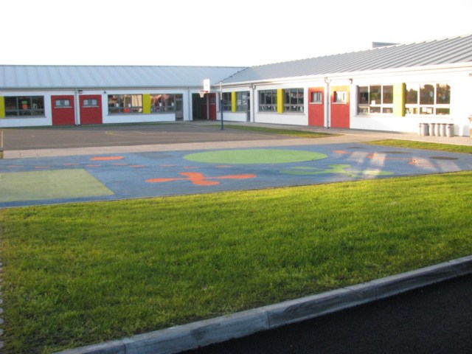

Scoil Bhríde

School Uniform Policy

SCHOOL UNIFORM POLICY

The Board, Staff and Parents Association have determined that the School Uniform is a fundamental part of the school identity and underscores all areas of school life. The policy has been updated in light of COVID-19. The following arrangement offers a range of choice while trying to minimise cost and allow for laundry days for families and ease of use for younger pupils all in an attempt to limit the spread of infectious disease.

The following School Uniform will be worn by all 1st class to 6th class pupils on
Tuesdays and Thursdays effective from September 2021:

- School Wine Jumper (with school crest): available to purchase from local suppliers
- School Tie: available to purchase from the school
- Grey shirt: Parents can choose where to purchase
- Grey trousers / skirt / pinafore: Parents can choose where to purchase.
- Appropriate footwear (e.g. black shoes etc.): Parents can choose where to purchase.

The following School Tracksuit will be worn by all 1st class to 6th class pupils on
Mondays, Wednesdays and Fridays effective from September 2021:

- Plain Navy tracksuit bottom (no stripes or markings): Parents can choose where to purchase.
- Royal blue hoodie (with gold school crest): available to purchase from local suppliers
- Grey polo shirt: Parents can choose where to purchase.
- Appropriate sports footwear: (Velcro fastening is best for younger children). Parents can choose where to purchase.

The following School Tracksuit will be worn by all Junior and Senior Infant pupils on Mondays, Tuesdays, Wednesdays, Thursdays and Fridays effective from September 2021:

- Plain Navy tracksuit bottom (no stripes or markings): Parents can choose where to purchase.
- Royal blue hoodie (with gold school crest): available to purchase from local suppliers
- Grey polo shirt: Parents can choose where to purchase.
- Appropriate sports footwear: (Velcro fastening is best for younger children). Parents can choose where to purchase.

All items of uniform must be labelled in case they get lost or mixed up.

If you have bought School Jumpers for the infant classes and want to get full use out of them by all means please do so. That is not a problem.
The Reasoning behind the School Uniform:

- Makes all pupils equal while creating a clear school identity.
- Represents a visible commitment to the rules and policies of Scoil Bhríde Nurney
- Establishes a code of dress appropriate to the image the school wishes to present.
- Reinforces a pride among the pupils in their school, particularly when representing the school on sporting or extra-curricular activities
- Reduces expense to parents of regularly having to purchase clothes for their children – often at the dictate of fashion.
- Pupils can clearly be distinguished from people who are not members of our school community thus making the school a safer environment for all (e.g. school-based tours, school and community celebration days etc.)

PLEASE NOTE: Pupils will sometimes get their school uniform/tracksuit dirty in school whether in class or in the Sports Hall or out on yard or out on the school field. This is part of school life and is unavoidable.

Uniform Enforcement Policy and Procedures:

To properly enforce the Uniform Policy, the school is again dependent on the support of you, the parents and guardians. Pupils are expected to adhere to the full school uniform as defined in the School Code of Behaviour. The School uniform reflects the sense of belonging to the school community and parity of esteem in which each individual is held. It must therefore be neat and correctly worn at all times, including going to, within and returning from school. It is neither possible nor practical for the school to operate exceptions to this policy, though we acknowledge that there will occasionally be genuine reasons why your child may arrive in school not wearing full uniform. The school may offer replacement school uniform items to pupils presenting out of uniform.

Enforcement Procedures are as follows:
- Pupils who have a genuine reason for being out of uniform should bring a letter signed by a parent/guardian to the teacher. This must be done first thing in the morning before 11am.
- At random times during the week a uniform inspection will be carried out by the school. Whole classes and individual pupils presenting in the full and proper school uniform, for the correct day, will be recognised and rewarded.
- Anyone not in full and proper school uniform will be asked for a letter/note explaining why. If there is no letter/note, a verbal reprimand will be given and the pupil’s name, class, issue and date will be logged in a uniform book.
- If the issue presents itself again without rectification, the pupil will be given time-out at break time.
- If the issue presents itself a third time without rectification, a letter will be sent to parents and the pupil will be placed on detention.

Persistent disregard for the school’s uniform policy will be addressed through the school’s Code of Behaviour and the Board of Management will deal with pupils refusing to co-operate with the policy.

Jewellery Policy

As parents and educators, we are all very conscious of the importance of our children’s health, hygiene, safety and happiness. The following policy regarding the wearing of jewellery etc. has been devised to minimise the risk of accident, injury or infection during school activities.

As a general ‘rule of thumb’ items or styles that are either an unnecessary distraction or a potential danger to oneself / another child, should not be worn to school. If you need to discuss any of the above please contact the school principal.

Items/styles that may be worn:
- Watches (not on swimming days – to avoid loss or damage)
- Plain stud earrings – one per ear (to be removed by pupil and stored by pupil during sport activities)
- Simple hair ties, clips or bands
- Any item required to highlight a certain medical condition e.g. medic alert bracelets

Items/styles that may not be worn:
- Rings of any description
- Necklaces, ‘chokers’
- Pendants, crosses & chains
- Elaborate hair decorations with sharp points
- Hair dye
- Bracelets
- Body piercing
- Earrings – other than plain studs
- Body art / tattoos
- Hair art/engraving
- False nails
- Heelies
- Any item not mentioned above that may be a distraction to learning

*Exceptions will be made for students engaged in staged performances on behalf of the school where any of the above items are so required for the duration of the staged performance(s).
The successful implementation of this policy is an important step in promoting a safe school environment for all children. All families and pupils are asked to co-operate with its implementation. This policy will be reviewed as required.

Ratification of School Uniform Policy

This policy was adopted by the Board of Management on _________________

Signed: _________________________ Signed: __________________________
Chairperson of Board of Management Principal

Date: __________________________ Date: __________________________

Date of next review: __________________

