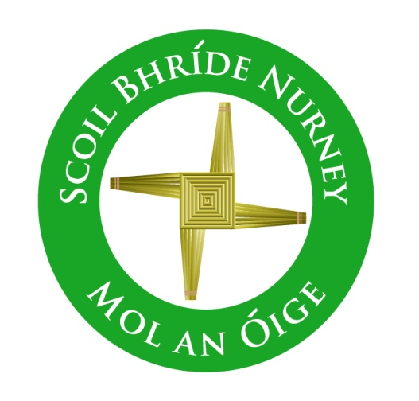
Internet Acceptable Use Policy (AUP)
2017+

Board of Management Scoil Bhríde Nurney
2017+
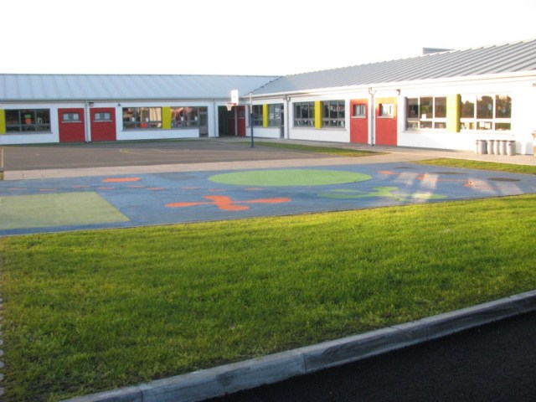

Scoil Bhríde

Internet Acceptable Use Policy (AUP)

Introduction:
The aim of this Internet Acceptable Use Policy (AUP) is to ensure that pupils will benefit from the learning opportunities offered by the school’s internet resources in a safe and effective manner.

Rationale:
Internet use and access is considered a school resource and privilege. If the school AUP is not adhered to this privilege may be withdrawn and appropriate sanctions will be imposed.

Aims/Objectives:
When using the internet pupils, parents and staff are expected:

- To treat others with respect at all times.
- Not undertake any actions that may bring the school into disrepute.
- Respect the right to privacy of all other members of the school community.
- Respect copyright and acknowledge creators when using online content and resources.

This Acceptable Use Policy applies to pupils who have access to and are users of the internet in Scoil Bhríde Nurney. It also applies to members of staff, volunteers, parents, carers and others who access to the internet in Scoil Bhríde Nurney.

Misuse of the internet may result in disciplinary action, including written warnings, withdrawal of access privileges, detention and, in extreme cases, suspension or expulsion. The school also reserves the right to report any illegal activities to the appropriate authorities.

Other policies associated with this Acceptable Internet Use Policy include Scoil Bhríde's Data Protection Policy, Child Protection Policy, Dignity at Work Policy, Safety Statement Policy, Supervision Policy, Education Management Software Policy, Mobile Phone and Electronic Devices Policy, Home Use of School Assistive Technology policy, Admissions Policy, Code of Behaviour Policy and Anti-bullying Policy.

Policy Content:

- General

Scoil Bhríde Nurney implements the following strategies on promoting safer use of the internet:

- Internet sessions will always be supervised by a teacher or staff member
- Filtering software and/or equivalent systems will be used in order to minimize the risk of exposure to inappropriate material
- Uploading and downloading of non-approved software will not be permitted.
- Virus protection software will be used and updated on a regular basis.
- The use of USB memory sticks, CD-ROMs or any future media types’ in school requires a teacher's permission. Pupils will not bring external storage devices such as pen drives (or memory sticks/USB keys etc) into school without permission.
- Students will observe good 'netiquette' (i.e. etiquette on the Internet) at all times and will not undertake any actions that may bring the school into disrepute.
- Pupils will be provided with education in the area of internet safety as part of our implementation of the SPHE curriculum.
- Internet safety advice and support opportunities are provided to pupils in Scoil Bhríde Nurney through ICT programmes where resources allow.
- Teachers will be provided with continuing professional development opportunities in the area of internet safety where resources allow.
- Scoil Bhríde Nurney participates in Safer Internet Day activities to promote safer more effective use of the internet.

- Content Filtering

Scoil Bhríde Nurney has chosen to implement the following level on content filtering on the Schools Broadband Network:

- Level 4 This level allows access to millions of websites including games and YouTube but blocks access to websites belonging to the personal websites category and websites such as Facebook belonging to the Social Networking category.

Pupils taking steps to by-pass the content filter by using proxy sites or other means may be subject to disciplinary action, including written warnings, withdrawal of access privileges, detention and, in extreme cases, suspension or expulsion.

- Web Browsing and Downloading

Pupils will not intentionally visit internet sites that contain obscene, illegal, hateful or otherwise objectionable materials.

Pupils will report accidental accessing of inappropriate materials in the classroom to their teacher.

Pupils will report accidental accessing of inappropriate materials in school but outside the classroom to the class teacher or the principal.

Pupils and staff will not copy information from the internet without acknowledging the creator and referencing the source of the content.

Pupils and staff will be aware that any usage, including distributing or receiving information, school-related or personal, may be monitored for unusual activity, security and/or network management reasons.

Pupils and staff will use the school’s internet connection only for educational and career development activities.

Pupils and staff will not engage in online activities such as uploading or downloading large files that result in heavy network traffic which impairs the service for other internet users.

Pupils will not download or view any material that is illegal, obscene, and defamatory or that is intended to annoy or intimidate another person.

- Email and Messaging

The use of teacher personal email accounts by school management (e.g. principal, school office) is only allowed at Scoil Bhríde Nurney with expressed permission from members of the teaching staff. The use of pupil personal email accounts and school email accounts by pupils is not allowed at Scoil Bhríde Nurney.

Pupils will not send any material that is illegal, obscene, and defamatory or that is intended to annoy or intimidate another person.

Pupils will not use school email accounts or personal emails. The use of pupil personal email accounts or school email accounts by pupils is not allowed at Scoil Bhríde Nurney.

Pupils should immediately report the receipt of any communication that makes them feel uncomfortable is offensive, discriminatory, threatening or bullying in nature and must not respond to any such communication.

Pupils should avoid opening emails that appear suspicious. If in doubt, pupils should ask their teacher before opening emails from unknown senders.

- Social Media

The following statements apply to the use of messaging, blogging and video streaming services in Scoil Bhríde Nurney:

- Use of instant messaging services and apps including Snapchat, Whats Apps, G Chat etc. is not allowed in Scoil Bhríde Nurney.
- Use of blogs such as Word Press, Tumblr etc. is is not allowed in Scoil Bhríde Nurney.
- Use of video streaming sites such as YouTube and Vimeo etc. is with express permission from teaching staff.

Staff and pupils must not use social media and the internet in any way to harass, insult, abuse or defame pupils, their family members, staff and other members of the Scoil Bhríde Nurney community

Staff and pupils must not discuss personal information about pupils, staff and other members of the Scoil Bhríde Nurney community on social media.

Staff and pupils must not use school email addresses for setting up personal social media accounts or to communicate through such media.

Staff and pupils must not engage in activities involving social media which might bring Scoil Bhríde Nurney into disrepute.

Staff and pupils must not represent your personal views as those of being Scoil Bhríde Nurney on any social medium.

- Personal Devices

The following statements apply to the use of personal technology, internet-enabled devices such as tablets, gaming devices, and digital music players in Scoil Bhríde Nurney:

- Pupils are not allowed to bring their own technology into school.
- Pupils are not allowed to bring personal internet-enabled devices into Scoil Bhríde Nurney.

- Images & Video

Care should be taken when taking photographic or video images that pupils are appropriately dressed and are not participating in activities that might bring the individuals or the school into disrepute.

At Scoil Bhríde Nurney pupils must not take, use, share, publish or distribute images of others without their permission.

Taking photos or videos of staff members on school grounds or when they are participating in school activities is only allowed with their expressed permission.

Taking photos or videos of pupils on school grounds or when they are participating in school activities is only allowed with expressed permission from pupils' parents.

Written permission from parents or carers will be obtained before photographs of pupils are published on the school website.

Pupils must not share images, videos or other content online with the intention to harm another member of the school community regardless of whether this happens in school or outside.

Sharing explicit images and in particular explicit images of pupils and/or minors is an unacceptable and absolutely prohibited behaviour, with serious consequences and sanctions for those involved. Sharing explicit images of other pupils automatically incurs suspension as a sanction.

- Cyber-bullying

When using the internet pupils, parents and staff are expected to treat others with respect at all times.

Engaging in online activities with the intention to harm, harass, or embarrass and another pupil or member of staff is an unacceptable and absolutely prohibited behaviour, with serious consequences and sanctions for those involved.

Measures are taken to ensure that staff and pupils are aware that bullying is defined as unwanted negative behaviour, verbal, psychological or physical, conducted by an individual or group against another person (or persons) and which is repeated over time. This definition includes cyber-bullying.

Isolated or once-off incidents of intentional negative behaviour, including a once-off offensive or hurtful text message or other private messaging, do not fall within the definition of bullying and will be dealt with, as appropriate, in accordance with the school’s code of behaviour.

The prevention of cyber bullying is an integral part of the anti-bullying policy of our school.

- School Website

Pupils will be given the opportunity to publish projects, artwork or school work on the internet in accordance with clear policies and approval processes regarding the content that can be loaded to the school’s website. Pupils will continue to own the copyright on any of their work published. The publication of pupil work will be coordinated by a teacher.

The website will be regularly checked to ensure that there is no content that compromises the safety, privacy or reputation of pupils or staff.

Scoil Bhríde Nurney will use only digital photographs, audio or video clips of focusing on group activities. Content focusing on individual students will only be published on the school website with parental permission.

Personal pupil information including home address and contact details will not be published on Scoil Bhríde Nurney web pages.

The Scoil Bhríde Nurney will avoid publishing the first or last name of pupils in video or photograph captions published online.

- Legislation

The school will abide by the current legislation regarding use of the Internet.

- Permission Form

The following ‘yes/no’ option appears on Scoil Bhríde’s enrollment form:

“As the parent or legal guardian of the above child, I have read the School’s Acceptable Internet Use Policy and grant permission for my son or daughter or the child in my care to access the Internet. I understand that Internet access is intended for educational purposes. I also understand that every reasonable precaution has been taken by the school to provide for online safety but the school cannot be held responsible if pupils access unsuitable websites accidentally or deliberately”

Success Criteria:
This policy and its implementation will be reviewed annually.

The school will monitor the impact of the policy using:

- Logs of reported incidents.
- Surveys and/or questionnaires of pupils, parents, and teaching staff.

Should serious online safety incidents take place within the school, the principal and class teacher should both be informed.

The implementation of this Internet Acceptable Use policy will be monitored by the principal.

Ratification of Internet Acceptable Use Policy (AUP)

This policy was adopted by the Board of Management on _________________

Signed: _________________________ Signed: __________________________
Chairperson of Board of Management Principal

Date: __________________________ Date: __________________________

Date of next review: __________________

