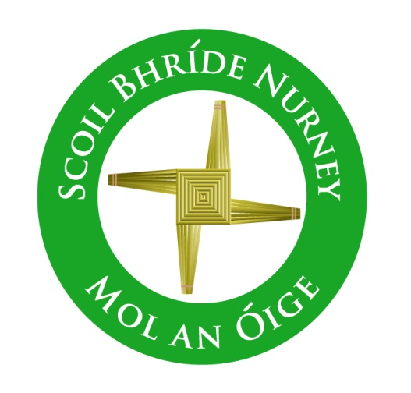
History Policy
2019+

Board of Management Scoil Bhríde Nurney
2019+
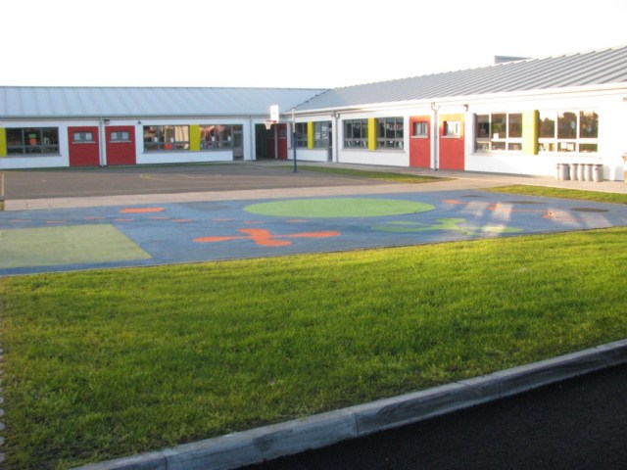
Scoil Bhríde

History Policy

Introductory Statement
This History Plan was drawn up in consultation and collaboration with staff members and its preparation involved review of current practice, research of Curriculum documents, NCCA materials and references to other materials and resources available in our school.

Rationale
Our plan has been designed to benefit the teaching and learning of History throughout our school. It provides an overview of the History curriculum and outlines our general aims and goals with regard to this subject. Our plan also provides frameworks for long term and short-term classroom planning for teachers. This plan is also designed to inform teachers (full time and temporary), our Board of Management and our parents and guardians of the approaches and methodologies used in teaching History.

Vision
We seek to assist the children in our school in achieving their potential. Our school hopes to promote a coordinated approach to the planning and teaching of History so as to ensure development and continuity and can facilitate the evaluation of learning, teaching resources and approaches and methodologies.
Aims
To provide the pupils of Scoil Bhríde Nurney with a history programme that is developmentally appropriate and socially relevant.

To support the aims of the primary curriculum for history by:
- developing an interest in and curiosity about the past
- making the child aware of the lives of women, men and children in the past and how people and events have had an impact upon each other
- developing an understanding of the concepts of change and continuity
- providing for the acquisition of concepts and skills associated with sequence, time and chronology, appropriate to the developmental stages of the child
- allowing the child to encounter and use a range of historical evidence systematically and critically
- providing opportunities for the child to communicate historical findings and interpretations in a variety of ways
- fostering sensitivity to the impact of conservation and change within local and wider environments
- helping the child recognise and examine the influences of the past on the attitudes and behaviour of people today
- fostering a willingness to explore personal attitudes and values and to promote an openness to the possibility of changing one’s own point of view
- encouraging the child to recognise how past and present actions, events and materials may become historically significant
- enabling the child to acquire a balanced appreciation of cultural and historical inheritances from local, national and global contexts.
The scheme covers the following five strands of the history curriculum –
- Local studies
- Story
- Early people and ancient societies
- Life, society, work and culture in the past
- Continuity and change over time

The following skills span the content of each of these five Strands
- Time and chronology
- Change and continuity
- Cause and effect
- Using evidence
- Synthesis and communication
- Empathy

The content of the History Scheme builds on the work at each prior level and will consolidate and develop the pupils’ experience, skills and historical knowledge in an environment that promotes enthusiasm, curiosity and creativity in the child.

Linkage and Integration
At each class level the teachers will seek to integrate History with other curricular areas. Teachers will make provision for this linkage in their short-term planning.

Methodologies
A variety of methodologies is an important aspect of the history programme as it helps children with differing learning styles to access the curriculum.
The following approaches will be employed to enhance each child’s history education;

- Talk and discussion-includes discrete teaching of discussion skills such as: turn –taking, active listening, positively responding to peers, clarity and confidence in giving opinions
- Using artefacts-an active learning hands on approach is encouraged with the free exploration of materials and ideas in an attempt to develop historian skills through content. As survivals from history, objects offer us an unrivalled way of touching past lives. For example, objects such as coins or old bottles can yield rich information and learning. They carry with them messages about the people who made, owned and used them, and about the places they came from and passed through.
- Guided and Discovery learning – by working historically based on an explorative and investigative approach through open questioning, observing, predicting, investigating, using evidence, observing both cause and effect and change and continuity, developing empathy, synthesising and communicating
- Collaborative and cooperative learning – Children have an opportunity to work together, share ideas and communicate their findings in pairs or groups, linking with other schools or project work
- Historical Language-for example whilst presenting the findings of research to the class or school
- Drama and role play - set in a specific historical context in an attempt to understand the identity/roles of the people involved in the situation, the time and place of the events and the issue that concerned the people involved.
- Story – For example using ‘Under the Hawthorn tree’ to convey information, ideas, and technical language through engaging children's imagination, create a context, providing a mental map and a visualisation of a past situation, serve the need for wonder, help children to understand human situations and the human condition, and thus connect the past to the present.
- Pictures and photographs - Visual images are powerful teaching and learning tools, providing windows into the past. Pictures are also sources of information. Pictures can be read as texts in their own right, not as mere illustrations. For example, Pictures of the Titanic and its various passengers can tell us a lot about 19th century western culture
- Documentary evidence - offers the full range of types and genres of writing, from letters and diaries to official speeches and reports, from narrative accounts to poetry of every kind, from instructions to persuasive arguments and advertisements. The historical context connects the children with the people, society and situation that produced a particular document, engaging them imaginatively in exploring its wider meaning. Reading historical documents includes reading as a technical exercise in comprehension and deconstruction, but goes way beyond this to the higher literacy of understanding meaning, situation and significance. For example, reading the daily log of Antarctic explorer Ernest Shackleton
- Using evidence and Problem-Solving- for example Did the Famine have a major impact on our village/town, Nurney/Kildare town, Why/why not? Using evidence to find answers, draw conclusions, make comparisons and raise more questions for further historical investigation
- Use of Environment- through investigative field work. Visits outside school open up new worlds. Historic sites are stimulating, real, three-dimensional; they give a sense of scale and texture. Whether you are visiting an archaeological site, a stately home, museum, castle, abbey, local street or church, the principles are the same for all. For example, visiting local houses in the locality, but built in different eras.
- Technology- to be used as a tool/ aid throughout third class. Classroom P.C.- to be used as a teaching tool/ aid to create data bases, to create spread sheets and to access supplementary materials and information from the internet. Websites- http://www.primaryhistory.org (for more see below)
- Oral evidence- interviewing people living and working in the local area about past events in the locality or family members about events in their own lives

Equality of Participation and Access
This History programme aims to meet the needs of all the children in the school. This will be achieved by teachers varying the pace, content and methodologies to insure learning for all pupils. We view the History programme as playing a key role in ensuring equality of opportunity for all children. The programme at each class level will be flexible so that the learning requirements of all children may be addressed. We provide an equal educational experience for both boys and girls as we recognise that stereotyped expectations of gender roles can inhibit children’s educational achievements. Children with special needs will be included in all activities

Differentiation
Whole class teaching of history will include a range of differentiation strategies by
- Differentiating learning objectives
- Differentiation by teaching style – using a mixture of whole class teaching and focused group work
- Differentiation by resource – for example using manipulatives or audio/visual resources or encouraging use of Historical websites for further investigation / study or using more accessible/more demanding evidence
- Differentiation by task – for example involving weaker / less interested pupils in setting up project or artefact stations etc. to stimulate interest and develop vocabulary or providing opportunities for children to record and tell about their historical findings in a variety of ways such as oral presentations, debates, drawing, role-playing, modelling, computer aided work
- Differentiation by outcome – for example modifying exercises to match the ability levels of pupils, for example opportunities for further investigation work
- Differentiation by grouping – for example using a ‘Buddy’ system to increase involvement of weaker pupils and give a sense of responsibility and caring for the more able or rotating group leaders when engaging in group work
- Differentiation by support – e.g. a list of the terminology used in history is given to the Support teacher or intervening to give the tuition they need as children are engage in learning activities

Assessment
Assessment is a continuous, dynamic and often informal process. Assessment in History will assess the child’s knowledge and understanding of the past, the acquisition of historical concepts and skills and the development of important attitudes and values.
The following assessment tools will be used;

- Teacher observation-this is ongoing and will be used to assess
- the responses pupils make to the teacher’s questions and suggestions
- the participation of pupils in whole-class discussions of historical characters, of their motives and actions, and of events in the past
- the interaction of pupils with each other in discussions and in group work
- the reaction of pupils to learning materials and learning tasks designed by the teacher
- the ways in which pupils react to and use historical evidence
- Teacher designed tasks and tests-including
- telling and retelling of events and stories
- oral, written and pictorial accounts and descriptions of sites visited or people interviewed
- construction of timelines, varying from simple ‘episodes in a story’ lines to more complex lines of historical periods
- work cards or activity sheets which guide and stimulate children in the examination of evidence or in researching a topic
- trail booklets which help the child to examine the evidence of the past in the environment or in an exhibition
- maps of historical sites
- role-playing or dramatising a conversation or event
- speculating on the feelings, emotions and motives of a character so as to create a spoken or written account (e.g. what Strongbow told his friend about Diarmaid Mac Murchú following their first meeting, the letter a nineteenth-century emigrant wrote to her mother in Ireland)
- drawing or completion of drawings
- model-making
- compilation of a book on a particular historical topic or the presentation of project work using information and communication technologies
- projects completed on historical themes
- interactive, multimedia computer programs which enable children to explore historical topics and complete a range of tasks, puzzles or problems. These programs adjust to the child’s level of knowledge or skill, give the child immediate feedback on his/her progress and, in some cases, may record information for the teacher about the progress of a number of pupils. Although useful, these programs may be of limited use in assessing historical skills
- results of the child’s independent historical research
- teacher-designed revision test on a unit or units of work.
- Concept mapping-pictorial and word-based relationship charts

- Work samples-written work or digitally stored samples used to affirm children’s progress and development, such as

- Completed work cards and booklets
- Models and artefacts
- Photographs of models constructed and areas visited
- History copybooks
- The results of project work
- Audio tapes of historical retellings or dramatizations

- Pupil profiles-compilation of test results and work samples, kept in folder in classroom and used for reporting to parents and other teachers.

- Curriculum profiles-used to record progress as children demonstrate mastery of indicators such as
- The child can use words and phrases about the passing of time
- The child can order objects correctly in chronological sequence

- Standardised testing- Micra –T and Sigma – T administered to all pupils according to the school’s assessment policy

- Diagnostic testing-administered by the support teacher, subsequent support strategies devised in consultation with class teacher etc.

Parental/Guardian Involvement
Some ways in which our parents/guardians can get involved include:
- Plan a visit to a living history museum with your child outside of school time. Take photos and collect maps and brochures for the school.
- Bring into the school any historical items you may have in your home, for the pupils to explore (e.g. photos, clothes, diaries, artefacts etc.)
- Collect newspapers for the school that are reporting major Historical moments (e.g. the Queen’s visit to Dublin etc.)
- Looking at & discuss work in history on the websites listed on the school website
- Getting other people involved in the history curriculum: helping to organise visitors to speak e.g. grandparents, retired teachers & other members of the community
- Our Parents Association is helping to fund some of our field trips.

Health & Safety
We are cognisant of the need to keep everyone and everything safe as we explore our environment. We teach children the rules and procedures for health & safety before and during walking trips and bus trips (this integrates with SPHE). The need to listen, respect and do as others tell us while is strongly emphasized)

Staff Development
- Teachers have access to reference books, resource materials, and websites dealing with History.
- Each teacher is responsible for keeping these resources up to date and to have these available to share.
- At times there may be appropriate SESE courses available. Teachers are encouraged to attend.
- Teachers are encouraged to share the expertise acquired at these courses as well as other aspects of the subject. This is organised at staff meetings.
- Working with local people who have good historical knowledge of the area benefits teachers and children alike.

Individual Teacher’s Planning and Reporting
Teachers will base their yearly and short-term plans on our whole school plan for History. Please refer to the attached whole school SESE planning guide for each class.

Teachers will consult this whole school plan and the curriculum documents for History when they are drawing up their long and short-term plans, ensuring that the correct strand units under each strand are taught.

Each teacher's Cuntas míosúil will assist in recording work covered and in evaluating progress in History and informing future teaching and learning.

Parents are informed of children’s progress in history at parent teacher meetings and in end of year report cards.

Organisational Planning
- Timetable
As per curriculum guidelines – SESE
- Infant Classes (2 hours 15 minutes per week)
- 1st – 6th Classes (3 hours per week)

SESE Project Fair
A simple project Fair is held annually in the school Hall (during the month of __________) with a different focus on one SESE subject project per year. All classes participate and the Fair is open to others to visit (e.g. year 1 – Science, year 2 – History, year 3 – Geography etc
Resources

The following resources will be made available and used in the delivery of the History Programme (this list will be updated after each review when possible):

- The environment itself
- a selection of artefacts dating from the 1700s to the present day
- picture books and/or story books
- word cards showing adjectives suitable for describing old and new things
- a class time line
- a picture pack or story book with pictures illustrating home life in a time beyond living memory
- a selection of Victorian or Edwardian household objects, eg candle holder, candle, lavatory chain, jug, bowl, towel stand, picture frame, paperweight, pen-and-pencil set, ink stand, Victorian game, companion set
- pictures or photographs of holidays in the past, eg from Big books, published photo-packs, family holidays. Photos showing holidays between 1900 and the 1970s are appropriate. To help with sequencing, these need to include obvious ‘clues’ to the period, eg forms of transport, clothes
- historical maps and charts
- artefacts and souvenirs
- a time line
- local, national and world maps
- information and educational resources about the effects of historical events on children
- historical novels
- non-fiction accounts
- a class time line from 3,000 BC to present day
- information about life in ancient civilisations
- replicas of ancient objects
- information various civilisations
- pictures of artefacts, aspects of life and seals
- local history books and booklets
- a range of old maps, including large-scale Ordnance Survey maps
- copies of old photographs, postcards or paintings
- documentary sources such as census returns, parish records and trade/street directories
- modern photographs of buildings and features in the area
- help may be available from staff at your library, local museum and the borough or county record office. Parents and older residents may give information from different perspectives
- The class History text book “Small World” by CJ Fallon
- Various picture scenes from the Famine
- Reading sheet and accompanying comprehension questions on famous historical characters
- A CD of “The Brendan Voyage”
- Various eyewitness accounts of historical events
- Know, Want to know, Learned board signs
- Blank sheets of writing paper
- Writer, reporter and speaker classroom coloured signs

General Resources
- Small World by CJ Fallon
- A variety of textbooks and the Local library
- Artefacts and books brought in by children/parents/teachers
- Relevant software
- Visualisers - this allows teacher to use one book with the entire class.
- History trails - local and further afield.
- Commercial History documents and kits
- Use of interactive whiteboard.

Areas of interest (local and further afield)
- Kildoon Woods
- Nurney Stream
- Nurney Playground and gardens
- Pigeon House
- School field
- School Garden
- Nurney Church
- Curragh Plains
- National Stud and Japanese Gardens
- Solas Bhríde grounds
- Saint Brigids Well
- Pollardstown Fen
- Kildare town and Cathedral and round tower

Websites
National Archives | www.nationalarchives.ie
National Museum | www.museum.ie
National Library of Ireland | www.nli.ie
Heritage Council | www.heritagecouncil.ie
Indus information | http://www.harappa.com/teach/
An Chomhairle Leabharlanna | www.askaboutireland.ie
http://www.primaryhistory.org/
www.primaryresources.co.uk/history/history.htm
www.teachingideas.co.uk/
www.schoolhistory.co.uk/primaryindex.html
www.scoilnet.ie
Egypt resources
http://www.dia.org/education/egypt-teachers/
Indus valley resources
http://www.harappa.com/teach/
www.qualityteachingresources.co.uk/

Success Criteria
The success of this plan will be measured using the following criteria:

- Teacher observation.
- Teacher designed tasks and tests.
- Samples of children's work e.g. projects, portfolios, art displays.
- Feedback from pupils and parents.
- Inspectors’ suggestions/feedback.
- Staff meetings so that time is given to discuss, review and amend if necessary.

Roles and Responsibilities
Class teachers are responsible for the implementation of the History programme in their own classes.

Ratification of History Policy

This policy was adopted by the Board of Management on _________________

Signed: _________________________ Signed: __________________________
Chairperson of Board of Management Principal

Date: __________________________ Date: __________________________

Date of next review: __________________

