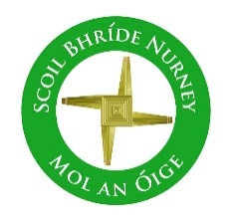
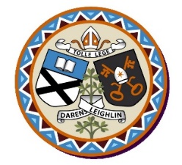
Scoil Bhríde Nurney
Annual Admission Notice
in respect of admissions to the 2023/2024 school year

Admission Policy and Application Form
A copy of the school’s Admission Policy and the Application Form for Admission for the 2023/2024 school year is available as follows: –
To download at: www.nurneyns.com
On request: By emailing sbnurney@gmail.com or writing to Scoil Bhríde, Nurney, County Kildare, R51YC66

Part 1 - Admissions to the 2023/2024 school year

Application and Decision Dates for admission to 2023/2024
The following are the dates applicable for admission to Junior Infants

The school will commence accepting applications for admission on | January 5th
The school shall cease accepting applications for admission on | February 15th
The date by which applicants will be notified of the decision on their application is | March 10th
The period within which applicants must confirm acceptance of an offer of admission is | March 31st

Note: the school will consider and issue decisions on late applications in accordance with the school’s Admission Policy.

Number of Places being made Available in 2023/2024

The number of places being made available in junior infants | 29

