Critical Incident Policy
2020+
Board of Management
Scoil Bhríde Nurney
2020+
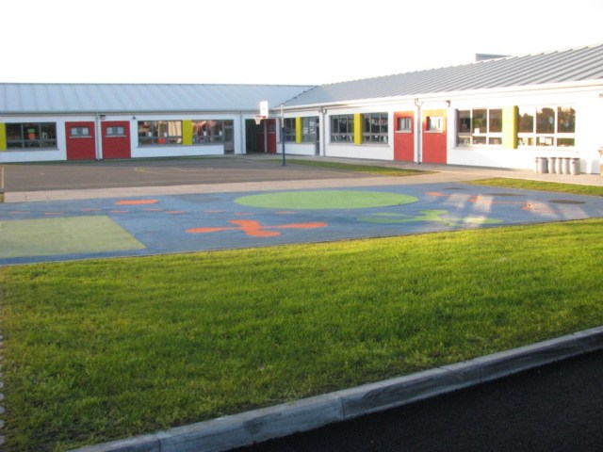
Scoil Bhríde

Critical Incident Policy

Critical Incident Management Plan

Introduction:

In Scoil Bhríde, Nurney, we aim to protect the well-being of our pupils and staff by providing a safe, tolerant and well catered for environment as outlined in our school philosophy statement.

The BOM through the Principal, the staff has drawn up a critical incident management plan. They have established a Critical Incidents Management Team to steer the development and implementation of the plan.

‘A critical incident is any sequence of events which overwhelms the normal coping mechanism of the school and disrupts the running of the school’

A critical incident may be any of the following examples.
- The death of a member of the school community through sudden death, accident, suicide or terminal illness
- An accident involving pupils or staff on or off the school premises
- A physical attack on pupil/staff member
- Intrusion into the school
- Serious damage to the school building
- Suicide
- A serious accident/tragedy in the wider community
- Disappearance of pupil from home or school
- Fire/natural disaster
- Outbreak of disease
The school aims to support its students and staff in the event of a critical incident. It also aims to create a coping supportive and caring ethos in the school.

Critical Incident Management Team:
‘It is a group from the BOM and staff of the school who know the school well enough to make the necessary decisions called for when an incident occurs’
One of the aims of the team is to return the school to the pre-incident, normal state as soon as possible.

The roles of the team are
- Team Leader
- Staff Liaison
- Pupils Liaison
- Parent Liaison
- Community Liaison
- Media Liaison

Critical Incident Management Team.

Chairperson Board of Management
Principal
Deputy Principal
Teachers

Team Leader; Chairperson of the Board of Management
- Alerts the team members to the crisis and convenes a meeting.
- Co-ordinates the tasks of the team
- Liaises with the Board of Management and Department of Education
- Liaises with the bereaved family
Staff Liaison; Principal
- Meets staff to brief staff on the facts as known, gives staff members an opportunity to express their feelings and outlines the routine for the day of vulnerable students.
Student Liaison; Teachers
- Liaises with other team members to keep them up-dated with information and progress.
Community Liaison; Chairperson
- Liaison with agencies in the community for support and onward referral.
- Updates team members on the involvement of external agencies.
- Co-ordinates the involvement of these agencies.
Parents Liaison; Principal
- Facilitates ‘questions and answers’ meetings.
- Meets with individual parents.
- Visits the bereaved family with the team leader.
Media Liaison; Deputy Principal
- With Team, prepare a public statement
- Ensure telephone lines are free for outgoing and important incoming calls
- Designate mobile numbers for contact
- Liaise with relevant outside support agencies
Creation of coping supportive and caring ethos in the school:
The following systems, which are already in place in our school or can be out in place in our school, help to lessen the probability of the occurrence of some incidents:

Physically Safe Environment – evacuation plan in place, fire drills take place termly, fir exits and extinguishers are regularly checked.

Psychologically Safe Environment –
SPHE programmes in place covering areas such as
- Grief and loss
- Stress/Anger Management
- Conflict Management
- Problem Solving
- Decision Making
- Communication Skills
- Alcohol and Drug Prevention
Students are protected and supported by the school Anti-Bullying Policy and peer support programmes.

Staff are vigilant for signs of depression.

If individual members of staff would like to pursue programmes in the area of Bereavement, Loss, Mental Health or Family Addiction, the Board of Management would offer any practical assistance it thought worthwhile.

Contact Numbers

Outside Agency | Contact Numbers
Gardaí | Kildare Town  045 521222  Monasterevin  045 525322
Hospital | Naas  045 849500  Portlaoise  057 8621364
Fire Brigade | Newbridge  045431370  Or  999 / 112
Health Board/Child and Family Centre | Athy  059 8633500
Inspectorate | 045 848518
NEPS | Naas  045848504  Dublin  01 8892700
DES Communications | 01 8896400
24 Hr Doctor (K-Doc) | 087 6596027  045 430893
Kildare Medical Centre | 045 521361
Local GPs | Dr Danny Mulvihill  045 521361  Dr Denis O’Dwyer  045 525566
Counselling | Rainbows/Sr. Cecilia  045 521481
Nurney Parish Office | 045 526737
Kildare Parish Office | 045 521352

Ratification of Critical Incident Policy

This policy was adopted by the Board of Management on _________________

Signed: _________________________ Signed: __________________________
Chairperson of Board of Management Principal

Date: __________________________ Date: __________________________

Date of next review: __________________

