Homework Policy
2021+

Board of Management Scoil Bhríde Nurney
2021+
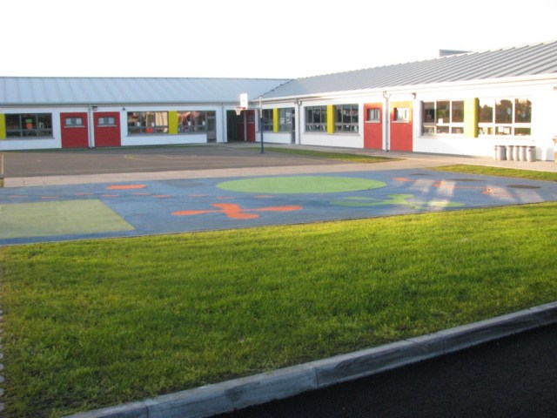

Scoil Bhríde

Homework Policy

Introduction:
This policy has been formulated by Scoil Bhríde Nurney to assist teachers in assigning appropriate homework for their pupils and to assist with the timely and accurate completion of homework under the supervision of their parents. This policy was written by the principal in conjunction with teaching staff following consultation with parents.

Why give homework?
- To reinforce what the child learns during the day
- To provide and reinforce links between school and home.
- To develop a child’s concentration skills and develop a work ethic

Aims/Objectives:
Children are assigned homework that supports and complements the work being carried out at school. This policy was written by the principal in conjunction with the teaching staff and following consultation with parents. The homework policy of Scoil Bhríde Nurney works in tandem with all other existing policies of the school.

The type of homework and amount will vary from time to time and from class to class increasing as the child progresses through the school. Parents are informed by the school at the start of the school year how much homework to expect and what kind and form it will take. This will be done through the School’s starting booklet for new pupils, the school’s website, the school’s weekly newsletter and individual teachers corresponding with parents outlining details as necessary.

Parents are encouraged to help their children to develop a positive approach to homework by setting aside a time in the day when they can complete their tasks.

Homework is set as a way of informing and involving parents in their child’s learning process, as well as enjoying activities and having fun.

Homework assignments in English and Mathematics and Gaeilge are given on a regular basis with particular emphasis on spellings and tables. Parental help with the learning of spelling and number patterns is much valued and has a noticeable impact on children’s learning

All pupils are encouraged to read in their own time every day. From an early age they will bring home their reading books the school hopes that parent and child will share the excitement of reading books together.

Parents are also encouraged to spend time allowing and supporting children to develop life skills by encouraging them to read things around them e.g. labels, street signs etc. as well as writing letters, stories, notes, lists and familiarize themselves with every day maths. This is supported and reinforced by staff during school time.

How often is homework given?
- Homework is generally given on Mondays, Tuesdays, Wednesdays and Thursdays but not on Fridays.
- Written Homework is generally given on Mondays, Tuesdays, Wednesdays and Thursdays but not on Fridays.
- In senior classes some project work may be undertaken at weekends
- Sometimes at the discretion of the class teacher or the principal, children are given “Homework off”
- Please note extra homework may be sometimes given during the week or at the weekend if a child has not done homework, made a suitable effort or presented untidy work.
- Written homework is not given during the first two weeks of September or the last two weeks of June
- Homework will not be assigned to pupils absent from school due to going on holidays even if requested.

How much time for homework?
The following are guidelines for time spent at homework. Different children will complete the same homework in different lengths of time. Time spent will vary from day to day and also from the beginning to the end of the school year. It is important to remember that it is the quality and not the quantity of homework that matters. The following are general guidelines only:

Class | Recommended Time
Junior infants, Senior infants and 1st class | 10 – 20 minutes
2nd class, 3rd class and 4th class | 20 – 30 minutes
5th and 6th class | 30 – 45 minutes

Homework Procedures:
- Homework always consists of reinforcing work/concepts covered in class and very rarely contains new material with which your child is unfamiliar.
- Homework assignments may involve research, writing, reading or learning and should be completed on time.
- The standard of any written homework assignment should be to the highest standard appropriate to the pupil’s ability. Children should be encouraged to have a sense of responsibility about their work.
- ‘Learning’ homework is every bit as important and often more important than written assignments and adequate time should be devoted to learning assignments.
- Homework assignments will be recorded in the pupil’s homework journal from 1st to 6th class. The journal will also act as a form of communication between the home and the class. It is important to inform the class teacher if a child is having difficulty with homework or if homework has not been completed on a specific day due to unavoidable circumstances. Parents should sign this diary on a daily basis and may include the amount of time it has taken the child to complete their homework if they so wish.
- Reading with a parent on a daily basis is to be encouraged.

How much help should parents give?
- Parents should try to help their children with homework by:
- Providing them with a suitable place and time to do their homework
- Preventing interruptions or distractions, like T.V., game consoles, mobile phones or other children
- Children should do written homework themselves and parents should only help when the child has difficulty
- If a child has difficulty with homework, the parents should help the child to overcome the difficulty with further explanation or examples, but not by actually doing the homework for the child. In this case the parent should write a note to the teacher explaining the problem
- Shared reading (especially right from the start in infant classes) is the most important homework and is meant to be an enjoyable exercise between parent and child.

How often should parents monitor homework?
- Parents should check and sign a child’s homework journal every evening
- The pupil’s journal is an important record of the child’s homework. It is also a valuable means of communication between parents and teachers. Ideally, all written messages to your child’s teacher should be put in the homework journal (additional pages available at the end of the journal)
- Please check that your child records his/her homework neatly and on the correct page and ticks each item of homework when completed

How often do teachers monitor homework?
- Ideally teachers like to check homework on a daily basis. However, with large class numbers it is not always possible to check each child’s homework journal every day
- As children get older and learn to work independently, some items of homework are checked less often e.g. every second day or once per week
- Some items of homework (and classwork) may be checked by children themselves under the direction of the teacher. This can be a useful part of the learning process for children.

When should parents communicate with the teachers about homework?
- When your child cannot do homework due to family circumstances
- When your child cannot do homework because she/he cannot understand some aspect
- If the time being spent at homework is often longer than the recommended amount of time.

When should homework be done?
- Each family situation is different - both parents working, child minders, etc. Ideally, homework should be done before any television is watched soon after school while your child is still fresh, however, some children need a break before starting homework
- Homework should never be left until morning time before school

Remember!

If homework is a stressful experience between parent and child, something is wrong! This leads to negative attitudes to learning, poor outcomes and defeats the whole purpose. Should this happen on a regular basis, please contact the class teacher.
Ratification of Homework Policy

This policy was adopted by the Board of Management on _________________

Signed: _________________________ Signed: __________________________
Chairperson of Board of Management Principal

Date: __________________________ Date: __________________________

Date of next review: __________________

