Time Spent on Each Subject Policy
2015+

Board of Management Scoil Bhríde Nurney
2015+
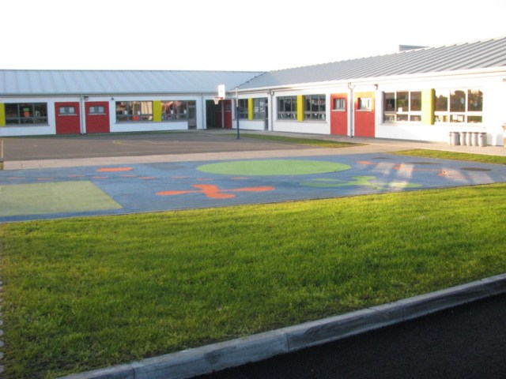

Scoil Bhríde

Time Spent on Each Subject Policy

The Primary School Curriculum (1999) suggests this weekly time allocation:

 | Full Day |  | Short Day  (infant classes)
Curriculum areas | One Week |  | One Week
 | Hours | Minutes | Hours | Minutes
Secular instruction
Language
L1 | 4 | 00 | 3 | 00
L2 | 3 | 30 | 2 | 30
Mathematics | 3 | 00 | 2 | 15
SESE | 3 | 00 | 2 | 15
SPHE | 0 | 30 | 0 | 30
PE | 1 | 00 | 1 | 00
Art education | 3 | 00 | 2 | 30
Discretionary curriculum time | 2 | 00 | 1 | 00
Total secular instruction | 20 | 00 | 15 | 00
Religious education (typically) | 2 | 30 | 2 | 30
Assembly time | 1 | 40 | 1 | 40
Roll call | 0 | 50 | 0 | 50
Breaks | 0 | 50 | 0 | 50
Recreation (typically) | 2 | 30 | 2 | 30
Total | 28 | 20 | 23 | 20

In 2011 the Department issued Circular 0056/2011 to order an increased time allocation for literacy and numeracy.

With effect from January 2012 all primary schools are required to:
- Increase the time spent on literacy, particularly in the first language of the school, by one hour overall for language (Irish and English) per week (i.e. to 6.5 hours for infants with a shorter day, and to 8.5 hours per week for students with a full day)
- Increase time on maths by 70 mins to 3 hours 25 mins per week for infants with a shorter day, and to 4 hours 10 mins per week for students with a full day.

Therefore schools now spend 8 30 (6 30) on Irish and English roughly broken down as 5 00 (4 00) on L1 and 3 30 (2 30) on L2. The new time allocation for maths is 4 10 (3 25)

Schools were asked to do this not by extending the school day but through a combination of approaches such as:
- integrating literacy and numeracy skills with other curriculum areas
- using some or all of discretionary time for literacy and numeracy activities
- re-allocating time spent on other subjects to literacy and numeracy
- prioritising most valuable curriculum objectives and delaying the introduction of elements of some subjects (for example, by delaying the introduction of strands and strand units from the history and geography curriculum for the infant classes and first and second classes to later in the primary cycle).

This increased emphasis on literacy and numeracy is not intended to lead to a narrowing of the curriculum: for example, while language lessons will provide some of the main opportunities to develop literacy skills, literacy can also be taught through many other aspects of the curriculum.

Therefore generally, time now allocated to each curriculum area is:

 | Full Day |  | Short Day  (infant classes)
Curriculum areas | One Week |  | One Week
 | Hours | Minutes | Hours | Minutes
Secular instruction
Language
L1 | 5 | 00 | 4 | 00
L2 | 3 | 30 | 2 | 30
Mathematics | 4 | 10 | 3 | 25
SESE  -10mins History  -10mins Geography  -10mins Science | 2 | 30 | 1 | 45
SPHE | 0 | 30 | 0 | 30
PE | 1 | 00 | 1 | 00
Art education  -20mins Drama  -10mins Art  -10mins Music | 2 | 20 | 1 | 50
Discretionary curriculum time  -60mins | 1 | 00 | 0 | 00
Total secular instruction | 20 | 00 | 15 | 00
Religious education (typically) | 2 | 30 | 2 | 30
Assembly time | 1 | 40 | 1 | 40
Roll call | 0 | 50 | 0 | 50
Breaks | 0 | 50 | 0 | 50
Recreation (typically) | 2 | 30 | 2 | 30
Total | 28 | 20 | 23 | 20
Ratification of Time Spent on Each Subject Policy

This policy was adopted by the Board of Management on _________________

Signed: _________________________ Signed: __________________________
Chairperson of Board of Management Principal

Date: __________________________ Date: __________________________

Date of next review: __________________

