CCTV Policy
2015+

Board of Management Scoil Bhríde Nurney
2015+
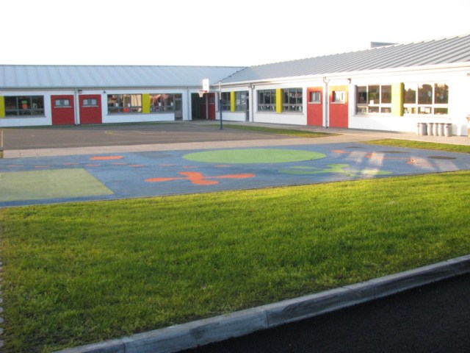
Scoil Bhríde

CCTV Policy

Introduction:
A Closed Circuit Television System (CCTV) is installed in Scoil Bhríde under the remit of the Board of Management.

Rationale:
The purpose of this policy is to regulate the use of CCTV and its associated technology in the monitoring of the environs of premises under the remit of the Board of Management of Scoil Bhríde.

Purpose of the CCTV System:
The CCTV system (5 cameras) is installed internally and externally on the premises for the purpose of enhancing security of the building and its associated equipment as well as creating a mindfulness among the occupants, at any one time, that a surveillance security system is in operation to deter crime, vandalism, theft, and bullying, as an aid to the promotion of high-quality Health and Safety standards and to the discharge of the school’s duty of care within and/or in the external environs of the premises at all times.

Scope of this policy:
This policy applies to all staff, pupils, and visitors to Scoil Bhríde. It relates directly to the location and use of CCTV, the monitoring, recording and subsequent use of such recorded material.

General Principles:
The Board of Management of Scoil Bhríde, as the corporate body, has a statutory responsibility for the protection of school property and equipment as well as providing a sense of security to its employees, students and invitees to its premises. Scoil Bhríde owes a duty of care under the provisions of Health, Safety and Welfare legislation and utilises the CCTV system and its associated monitoring and recording equipment as an added mode of security and surveillance for the purpose of enhancing the quality of life in Scoil Bhríde by integrating the best practices governing the surveillance of its premises.

The primary aim of the CCTV system in Scoil Bhríde is to deter crime and vandalism and to assist in the protection and safety of the said property and its associated equipment and materials.

Monitoring for security purposes will be conducted in a professional, ethical and legal manner and any diversion of the use of CCTV security technologies and personnel for other purposes is prohibited by this policy.

Information obtained through video monitoring may only be released when authorised by the Principal, following consultation with the Chairperson of The Board of Management.

CCTV monitoring of public areas, for security purposes, will be conducted in a manner consistent with all existing policies adopted by the Board of Management including the provisions set down in Equality and other Education related legislation.

The industry code of practice for video monitoring prohibits monitoring based on the classifications contained in Equality and other related legislation e.g. gender, marital status, family status, sexual orientation, religion, age, disability, race or membership of the Traveller community.

Video monitoring of public areas, for security purposes, within Scoil Bhríde is limited to areas that do not violate the reasonable expectation to privacy as defined by law.

Data from the CCTV system will be accessed and used in accordance with Data Protection Regulations.

Cameras are located in the following areas:

Internal
- School front reception area

External
- School porch
- Oil tank
- Rear school exit door
- Rear school fence

Signage is erected at the school entrance advising that a CCTV System is in operation at the school. The signage includes the name and contact details of the data controller as well as the specific purpose for which the CCTV cameras are in place.

Staff, pupils and parents/guardians are informed of the location and purpose of the CCTV system as outlined above. The right to access images captured by CCTV cameras shall be in accordance with the Data Protection Acts of 1998 and 2003, and as per Scoil Bhríde Data Protection Policy.

Data Protection:
All personal data recorded and stored by the CCTV system is governed by the Data Protection Acts of 1998 and 2003. Under the Data Protection Acts a data controller is the individual or the legal person who controls and is responsible for the keeping and use of personal information in manual files or in a computerised form. The data controller in respect of images recorded and stored by the CCTV system in the school is the Principal on behalf of the Board of Management.

The personal data recorded and stored by the CCTV system will only be available to the data controller and will be used only for the purposes outlined in this Policy.

Individuals whose images are recorded and stored by the CCTV system shall have the right to request and receive a copy of personal data processed by the system. Such requests shall be made in writing to the data controller and shall be complied with within a maximum of 40 days. Personal data recorded by the CCTV system shall be retained for a maximum of 31 days. Thereafter it will be deleted automatically.

The recorded footage and the monitoring equipment shall be securely stored in the Lock-up room. Unauthorised access to this place is not permitted at any time. The Lock-up room is secured by means of a key locking system.

The following procedures shall be followed in the event that An Garda Síochána seeks to view or take a copy of CCTV footage from the school’s CCTV systems:

- The data controller shall satisfy himself/herself that there is an investigation underway
- A request from An Garda Síochána must be made in writing on Garda Síochána headed notepaper.

All CCTV systems and associated equipment are required to be compliant with this Policy.

Responsibilities:

The Board of Management will:
- Ensure that the CCTV Policy is in place, compliant with relevant legislation, to govern the use of CCTV in the school
- Ensure this Policy is reviewed regularly by the Board of Management.

The Principal will:
- Act as Data Controller on behalf of the Board of Management
- Ensure that the use of the CCTV system is used in accordance with this Policy as set down by the Board of Management
- Oversee and co-ordinate the use of CCTV monitoring for safety and security purposes within the school
- Ensure that all CCTV monitoring systems are compliant with this Policy
- Be responsible for the release of any information or material in compliance with this Policy
- Maintain a record of the release of any material recorded or stored on this system
- Provide a list of the CCTV cameras, their locations and the associated monitoring equipment and the capabilities of such equipment to the Board of Management for formal approval
- If required, approve the location of temporary cameras to be used during special events that have particular security requirements and ensure their withdrawal following such events
- Ensure that all areas being monitored are not in breach of a reasonable expectation of the privacy of individuals within the school
- Advise the Board of Management to ensure that adequate signage, at appropriate and prominent locations, is displayed
- Ensure that external cameras are not intrusive in terms of their positions and views of residential housing and comply with the principle of ‘reasonable expectation of privacy’
- Ensure that recorded material is retained for a period not longer than 31 days and will be erased unless required as part of a criminal investigation or court proceedings, criminal or civil, or other bona fide use as approved by the Board of Management
- Ensure that monitors are stored in a secure place with access by authorised personnel only.

Links to Other Policies and to Curriculum Delivery:
All school policies are consistent with one another, within the framework of the overall School Plan. Relevant school policies already in place, being developed or reviewed, are examined with reference to the CCTV Policy and any implications which it has for them are addressed.

The following policies are among those considered:
- Data Protection Policy
- Child Protection Policy
- Anti-Bullying Policy
- Code of Behaviour
- Mobile Phone Policy
- ICT Acceptable Usage Policy

The CCTV Policy has been developed mindful of the school’s obligation under Data Protection Legislation.

Implementation Arrangements, Roles and Responsibilities:
The School Principal is assigned the role of co-ordinating implementation of this CCTV Policy and for ensuring that all members of the school community are familiar with the Policy.

Monitoring the implementation of the Policy:
Staff and Board of Management members will satisfy themselves on an on-going basis that the actions/measures set down under the Policy are being implemented.

Reviewing and evaluating the Policy:
Ongoing review and evaluation of this Policy will take cognisance of changing information or guidelines (e.g. from the Data Protection Commissioner, Department of Education and Skills or the NEWB), legislation and feedback from parents/guardians, students, school staff and others. The Policy will be revised as necessary in the light of such review and evaluation and within the framework of school planning.

Success Criteria:
Practical indicators that will be used to gauge the impact and effectiveness of the policy will include the extent to which:
- Students, staff and parents/guardians are aware of the policy
- Requests for access to personal data are dealt with effectively
- Personal data records are held securely
- Personal data records are retained only for as long as necessary.

Ratification of CCTV Policy

This policy was adopted by the Board of Management on _________________

Signed: _________________________ Signed: __________________________
Chairperson of Board of Management Principal

Date: __________________________ Date: __________________________

Date of next review: __________________

