5 Year Digital Learning Plan 2017 – 2022
2016+

Board of Management Scoil Bhríde Nurney
2016+
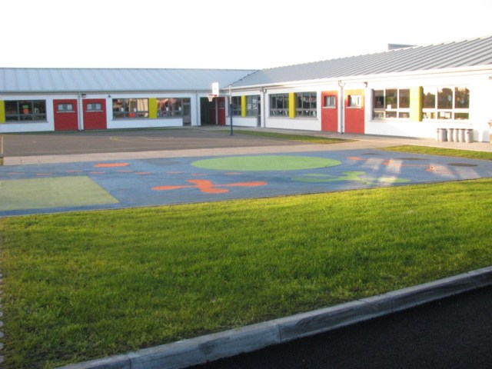

Scoil Bhríde

5 Year E-Learning Plan 2017 – 2022

Introduction:
The development of this plan was set out as a priority area by the school to comply with the Department of Education publications ‘circular 0001/2017’ and ‘Digital Strategy for Schools’.
There are four key aspects to this plan:
- Overall approach to e-learning to include the role of school leadership, planning for e-learning and the vision of an e-learning culture in the school.
- ICT in the curriculum, to include targets for each class level and examples of best practice in the school.
- Professional development issues, to include staff training.
- The ICT infrastructure in the school, to include a maintenance and refurbishment plan, budget and technical issues.
Overall approach towards e-learning:
Vision for e-learning here in Scoil Bhríde:
In line with the guidance provided by the National Council for Technology in Education (NCTE), the approach in Scoil Bhríde is to emphasize the integration of ICT across the curriculum, in order to improve the quality of teaching and learning. Therefore ICT is not a subject or a curriculum in its own right. It is a tool that can add value to the teaching and learning process when it is used appropriately. The purpose of computer literacy is the same as all teaching and learning, to awaken and to support the development of intellectual curiosity.
However, parents and teachers can overestimate the benefits of exposure to ICT for children. Some suggest that technology does little beyond distract children from real learning opportunities much of which could better be accomplished by pen and paper and traditional teaching. While children may have a passionate engagement with technology, some research suggests that it can lead them to trial and error responses (click and see) and guesswork answers. Technology can detract from time spent socially, from imagining.
At the same time, we are educating children who live in a technological age (digital natives) and so our teaching and learning must reflect that reality. Pedagogically, e-learning can be highly motivating for the learner and particularly for those children who find the more traditional methodologies of the school setting constraining. In that light, we will strive to maximize the potential for children’s learning using ICT, where appropriate.
Our vision for e-learning is about trying to ensure that the children begin to develop a critical appreciation of the role of ICT in society and develop habits which reflect an ethical and responsible use of ICT.

Scoil Bhríde is committed to the implementation of an e-learning policy based on the following principles:
- ICT is a cross curricular tool, not a subject in its own right
- ICT is an essential part of the administration of the school
- Schools have a role to ensure that all pupils in the school, not just those with access to technology at home, can access an e-learning environment
Circular 0001/2017
Our 5 year plan has been created using the 5 criteria from the Digital Schools of Distinction. This is broadly similar to the four themes in Circular 0001/2017 and provides us with a concrete, practical, incremental and sustainable roadmap that we can follow and build upon over the next 5 years

National Digital Strategy
Our 5 year plan broadly reflects the 4 themes in the National Digital Strategy through the implementation of the Digital Schools of Distinction.

Criteria 1 (Theme 1):
ICT integration in the Curriculum (Teaching, Learning and Assessment using ICT)
Indicators of success:
- Formulate clear statements regarding digital skills and learning outcomes in our school plan
- Formulate an e-learning plan and digital strategy
- Avail of CPD for teachers giving examples of practice on the use of ICT for teaching, learning and assessment
- Avail of and make available high-quality digital content to support learning and teaching
- DIGITAL LEARNING FRAMEWORK FOR PRIMARY SCHOOLS – Teaching and Learning
Domain 1: Learner Outcomes
Domain 2: Learner Experiences
Domain 3: Teacher’s Individual Experience
Domain 4: Teachers’ Collective/Collaborative Practice

Criteria 2 (Theme 2):
Continuing Professional Development (Teacher Professional Learning)
Indicators of success:
- Recognise the role and potential of ICT to enhance teaching and learning in your school plan
- Avail of Department funded support services on the use of ICT
- Guidance and examples of good practice on the effective, critical and ethical use of ICT for teaching, learning and assessment are provided to and shared by teachers
- DIGITAL LEARNING FRAMEWORK FOR PRIMARY SCHOOLS – Teaching and Learning
Domain 3: Teacher’s Individual Experience
Domain 4: Teachers’ Collective/Collaborative Practice

Criteria 3 (Theme 3):
Leadership and Vision (Leadership, Research and Policy)
Indicators of success:
- Recognise the role and potential of ICT to enhance teaching, learning and assessment
- Structures are established to provide oversight of and guidance on the implementation of the strategy
- Avail of guidance, planning resources and related supports for the effective, safe and ethical use of ICT
- Appropriate linkages are developed with other school policies
- DIGITAL LEARNING FRAMEWORK FOR PRIMARY SCHOOLS – Leadership and Management
Domain 1: Leading Learning and Teaching
Domain 2: Managing the Organisation
Domain 3: Leading School Development
Domain 4: Developing Leadership Capacity

Criteria 4 (Theme 4):
Resources and Infrastructure (ICT Infrastructure)
Indicators of success:
- Avail of improved connectivity with ICT funding for the Department
- Avail of grants scheme for the purchase of equipment
- Avail of guidance and advice for the purchase of equipment and services
- Avail of guidance on the innovative use of ICT for teaching and learning

Criteria 5 (): School ICT Culture ()

Year | Theme 1:  Teaching, Learning and Assessment using ICT  (ICT in the curriculum) | Theme 2:  Teacher Professional Learning (Professional Development) | Theme 3:  Leadership, Research and Policy  (Leadership and vision) | Theme 4:  ICT Infrastructure  (Resources and infrastructure) | School ICT Culture
1 | *Embed the use of some tools/apps that align with and enhance work in a priority area (e.g oral language)  *Start to use IEP writer  *introduce Primary Planning Tool | *Audit professional development needs  *Develop a plan for professional sharing within staff in Oral language and ICT (PDST) | *Use activities from the Summer Course to cultivate a commitment to change  *ICT survey among staff regarding ICT strengths and weaknesses in our school | *Audit of resources and with ICT Grant invest in ICT infrastructure improvements e.g. (i) improve wifi (ii) upgrade and repair current stock of laptops and PCs | *Use the online roll book  *Introduce online payments  *introduce Aladdin for texting parents, BOM etc.
2 | *Embed the use of some tools/apps that align with and enhance work in a priority area (oral language ) by passing on Summer course log information to staff  *An internet safety lesson at the beginning of every school year in every class (make it part of school policy)  *classes to start uploading work samples on the school website  *fully roll out Primary planning Tool for the new language curriculum  *Formulate clear statements regarding digital skills and learning outcomes in our school plan | *Apply for PDST support to work on the school's focus area (ICT)  * Complete a Summer course on leading ICT in the school | *Complete DSOD evaluation online  * Develop an e-learning plan  * Develop an AUP policy  *Develop an ICT policy  *Give an e-learning road map to every staff member to fill in as a survey to give us a whole school picture | *Use ICT grant to either (i) purchase more laptops and ipads (ii) improve wifi further with Colms idea or (iii) invest in two or three PCs per class or set up computer room (ask staff)  *Purchase more ethernet cables  * Set up a school Drop Box account | *Embed a simple parent or pupil survey in the website to assist with the SSE process  *Make policies available on the website  *Put webwise link on school website for parents and staff  *Use Aladdin to record pupil notes
3 | *Embed the use of a tools/app that align with and enhance work in the priority areas of literacy and numeracy, aid assessment and engage parents (e.g the “Achieve Online Learning” platform www.aoll.ie) |  |  | - Get e-fibre | - Set up a staff ‘whats app’ group
4
5

Success Criteria:

How will we know for sure that the plan is working in classrooms?

- Annual review of the “Indicators of Success”
- The Principal will issue each teacher every month a page pertaining to the Digital Learning Plan, in which teachers will write in brief bullet points what ICT they used and in what subjects each month and return it to the Principal.

Class: | School Year: | Month:
Subject | ICT used (bullet points)
Maths

English

Gaeilge

SPHE

PE

Drama

Art

Music

History

Geography

Science

Ratification of 5 Year Digital Learning Plan 2017 – 2022

This policy was adopted by the Board of Management on _________________

Signed: _________________________ Signed: __________________________
Chairperson of Board of Management Principal

Date: __________________________ Date: __________________________

Date of next review: __________________

